Nongtalang College, Nongtalang

Renovation of Building (Classroom)

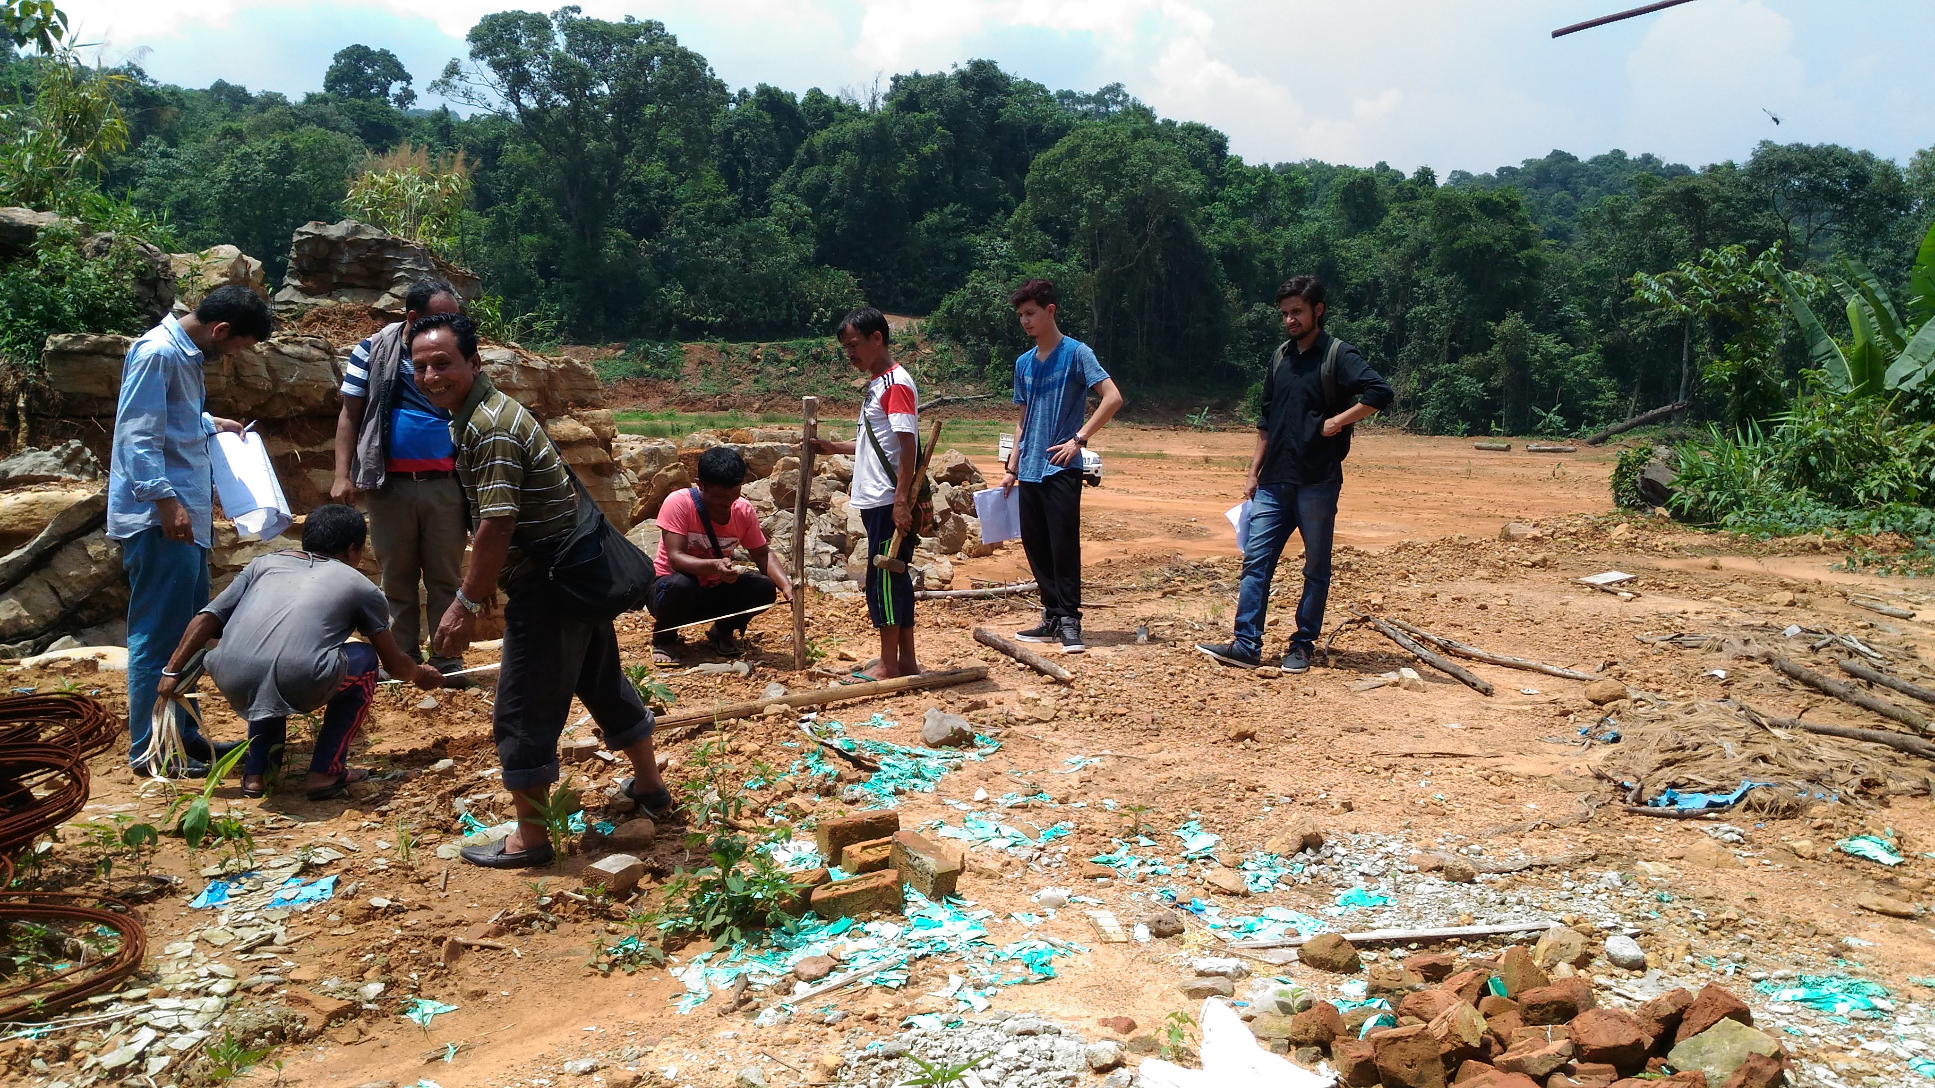
Land Allotment by Architect for Renovation & up-gradation of Classroom Dt:07-06-2017

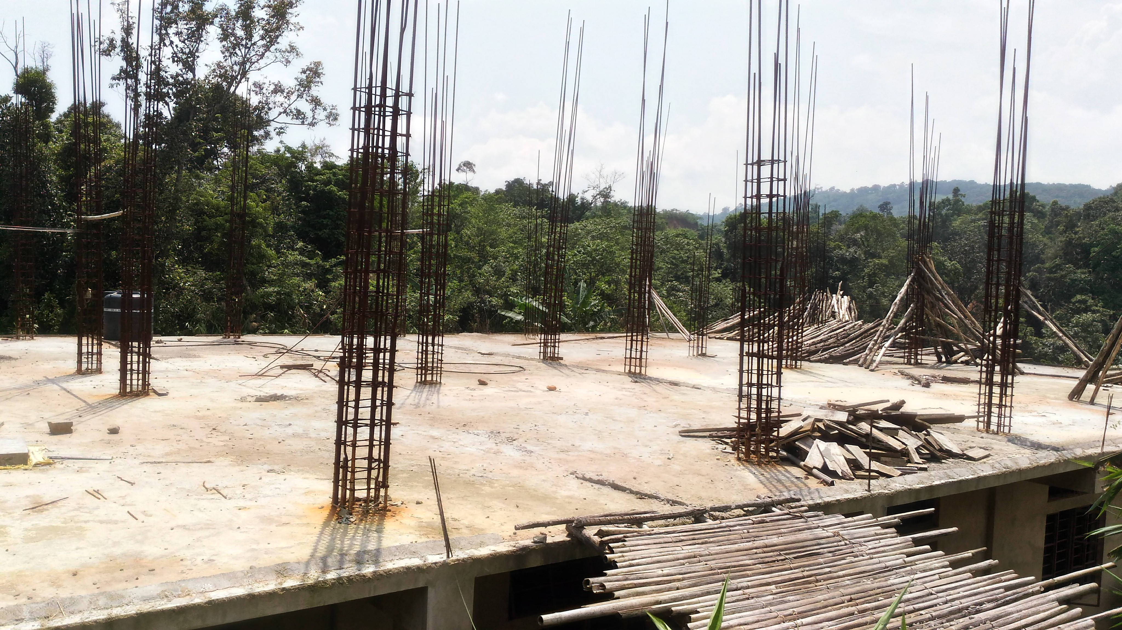
Renovation & up-gradation of Classroom on 1 floor of Existing classroom building Dt:07-06-2017

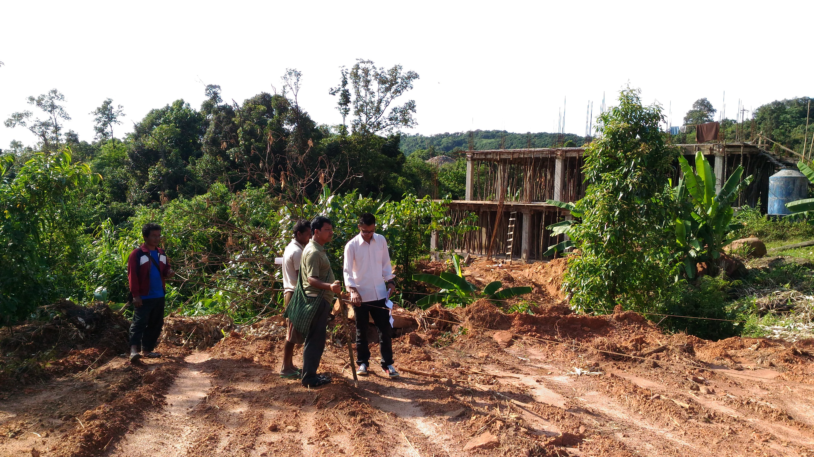
Renovation & up-gradation of Classroom on 1 floor of Existing classroom building (Back Side) Dt:31-10-2017

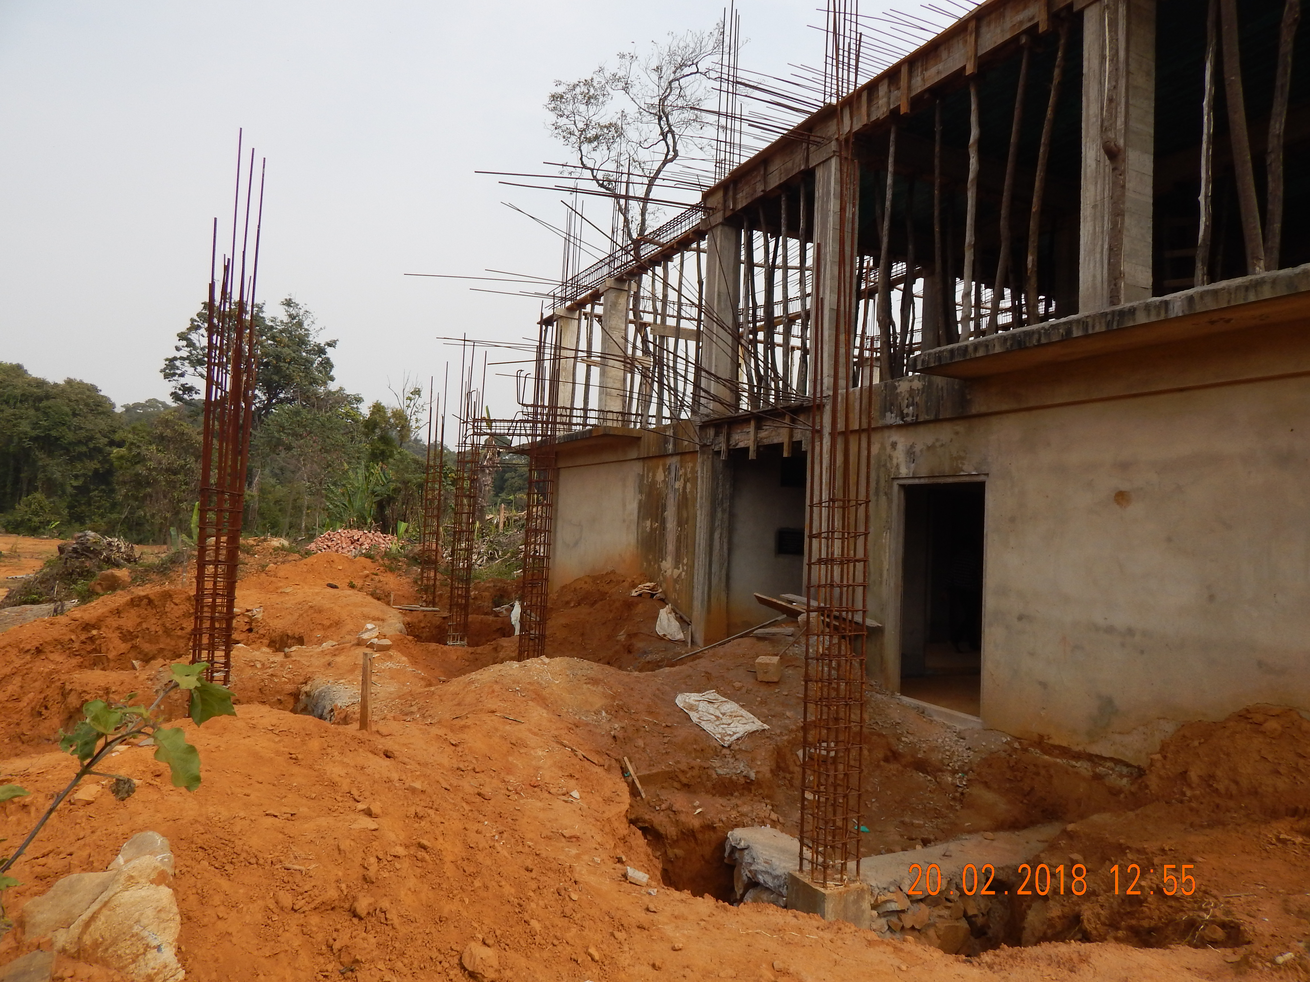
Front Side of Classroom (Renovation & up-gradation of Classroom on 1 floor of Existing classroom building Dt:20-02-2018)

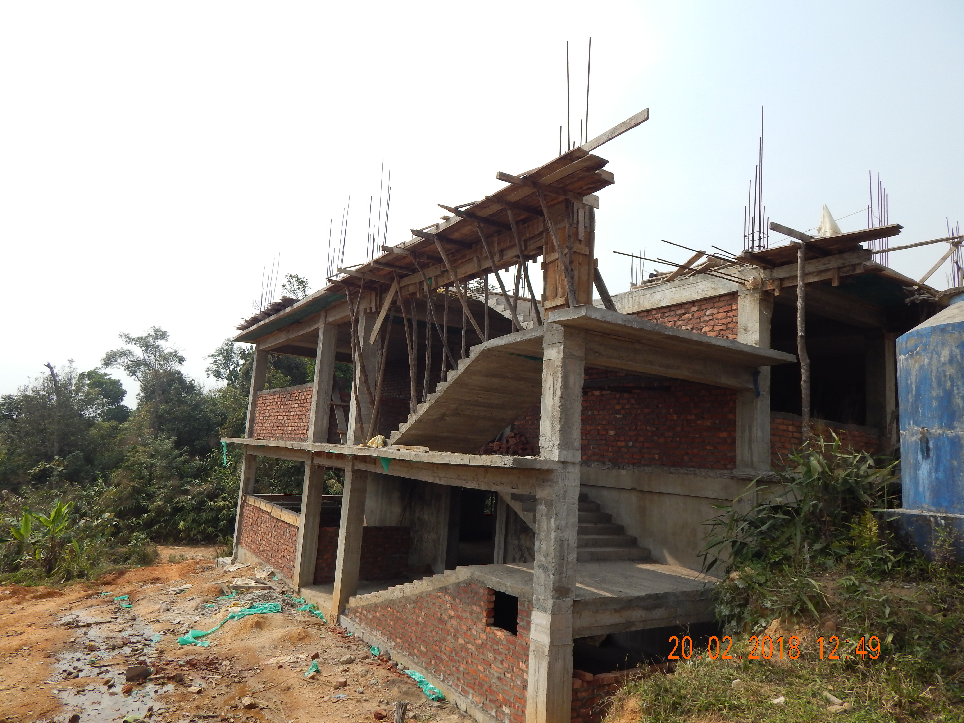
Renovation & up-gradation of Classroom – Staircase & Wall/brick construction Dt:20-02-2018
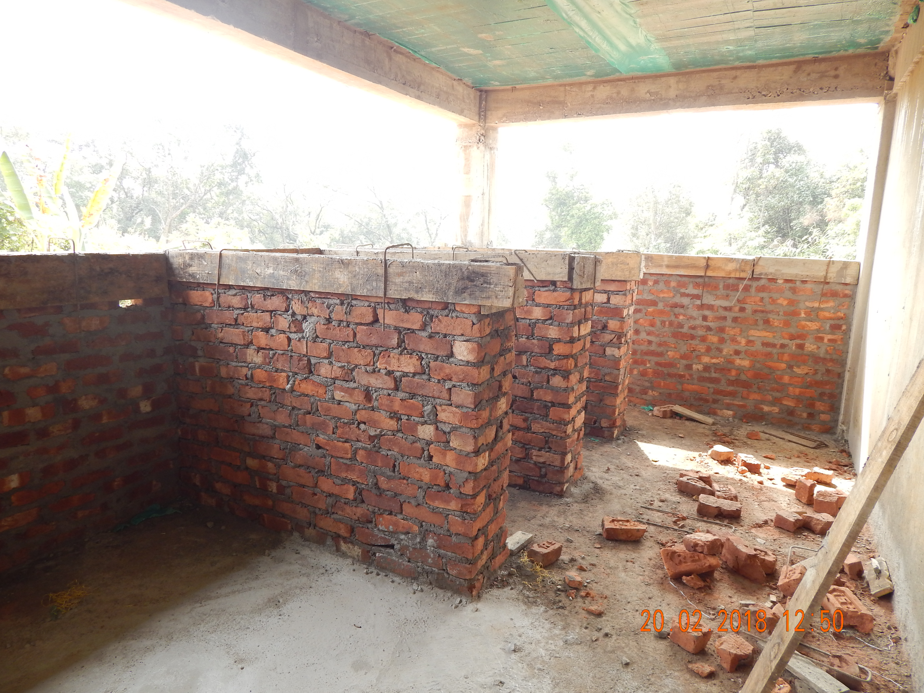
Construction of Toilet on 1st floor of Renovation & upgradation of Classroom Dt:20-02-2018

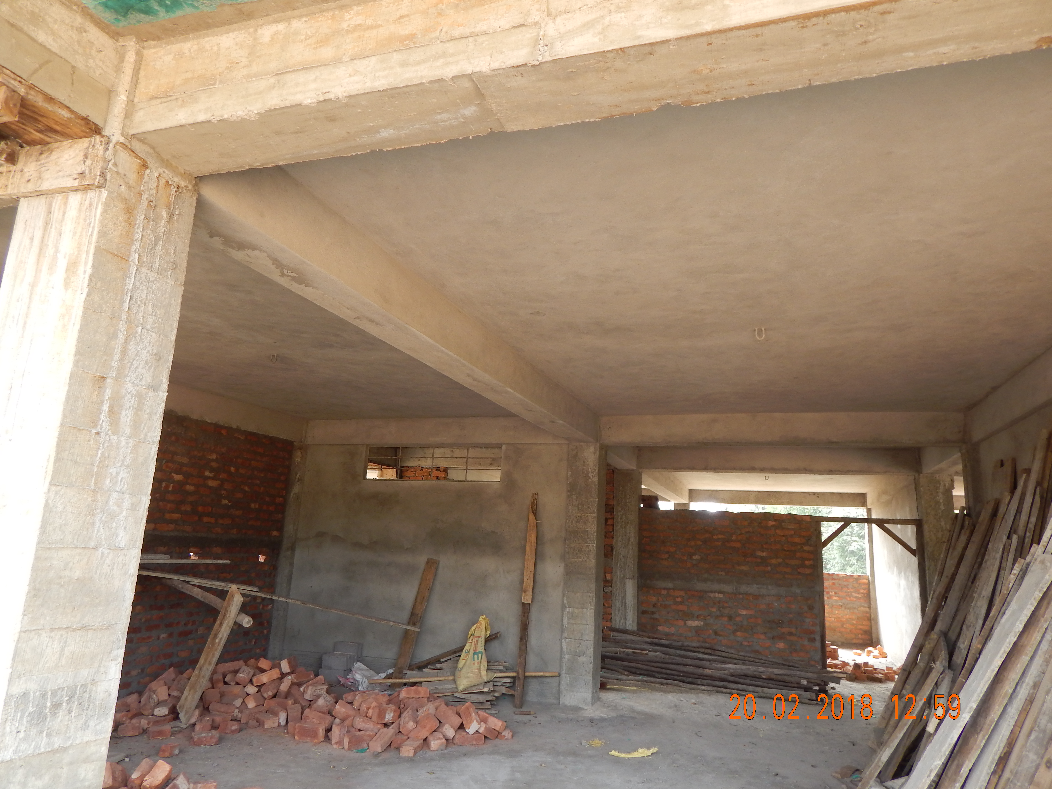
Construction of Wall/ Brick Dt:20-02-2018

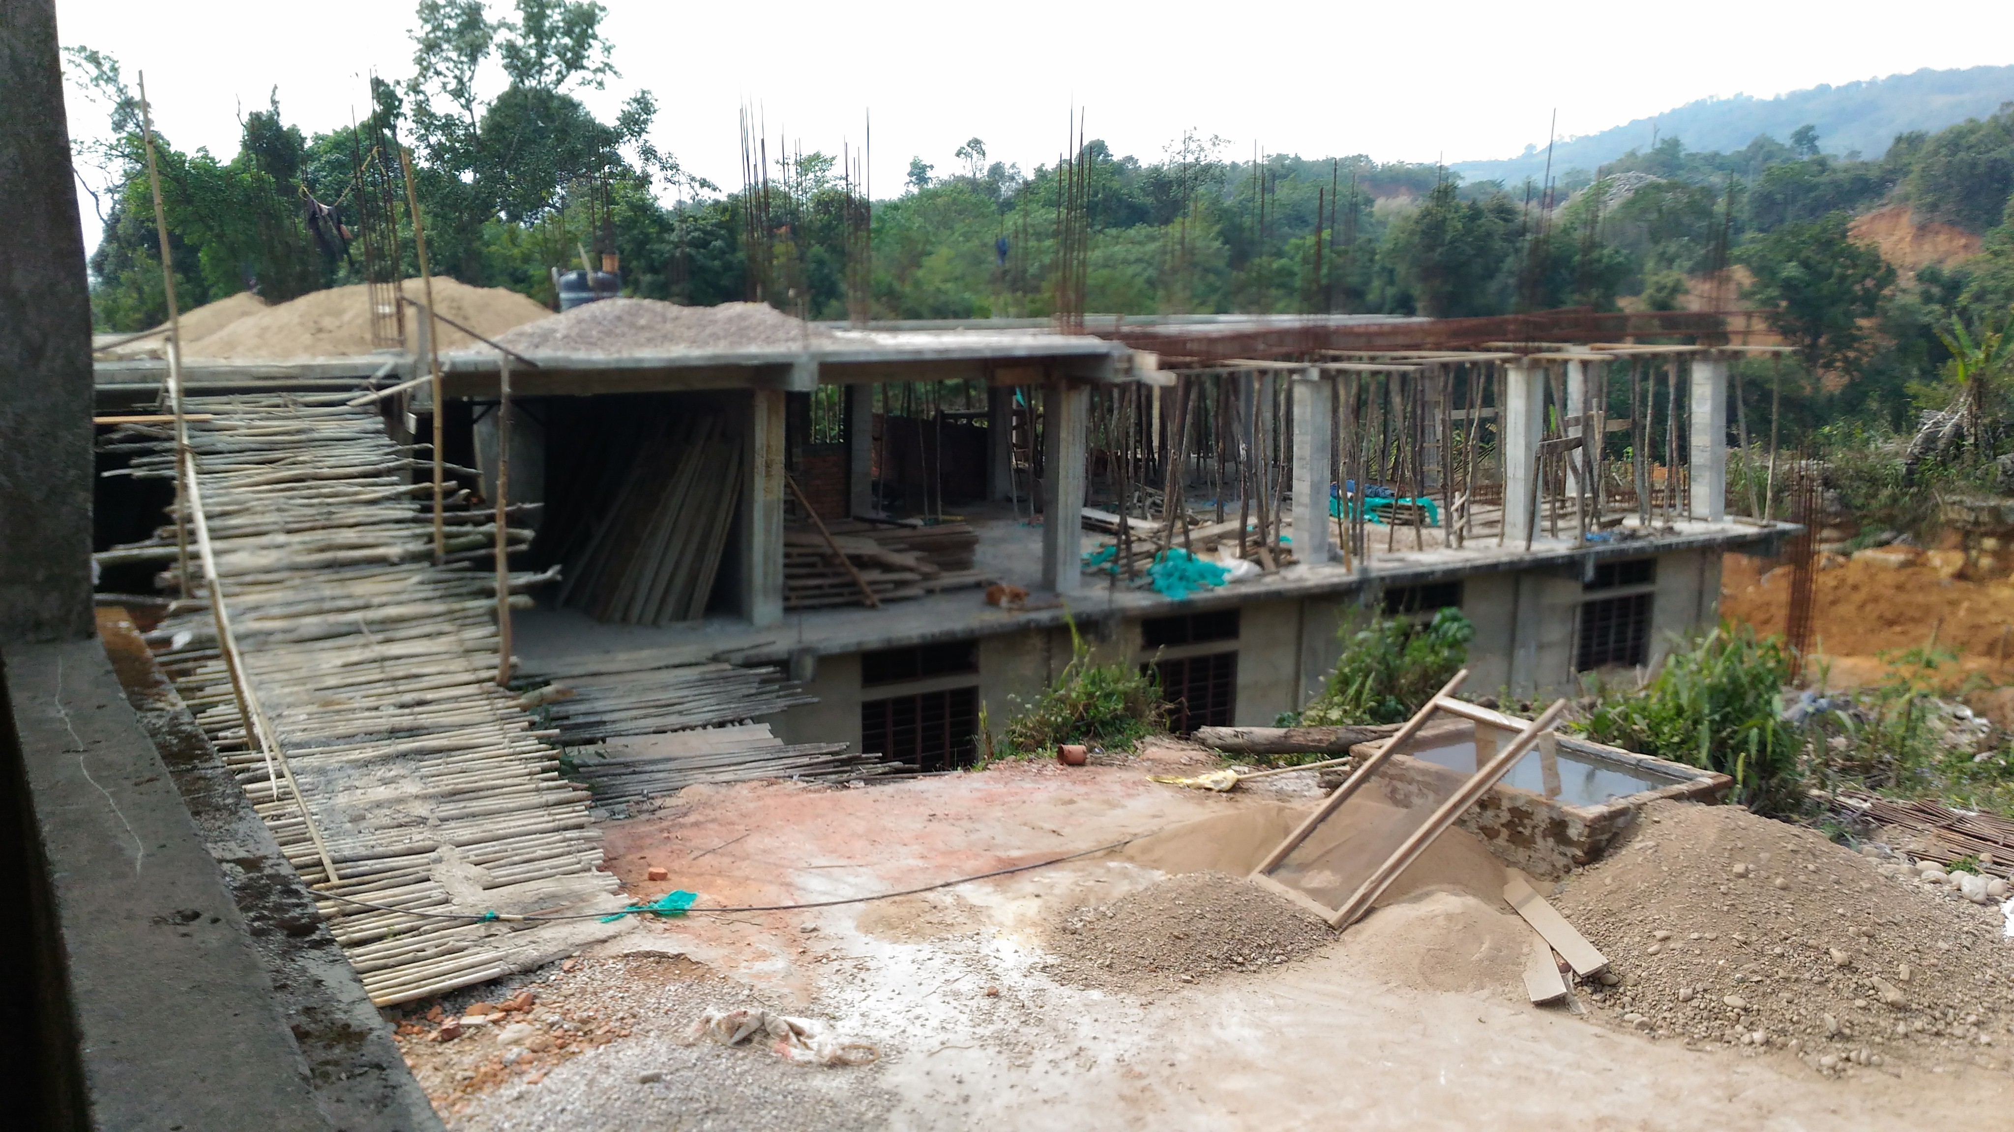
Slab/roof Construction Dt:20-02-2018
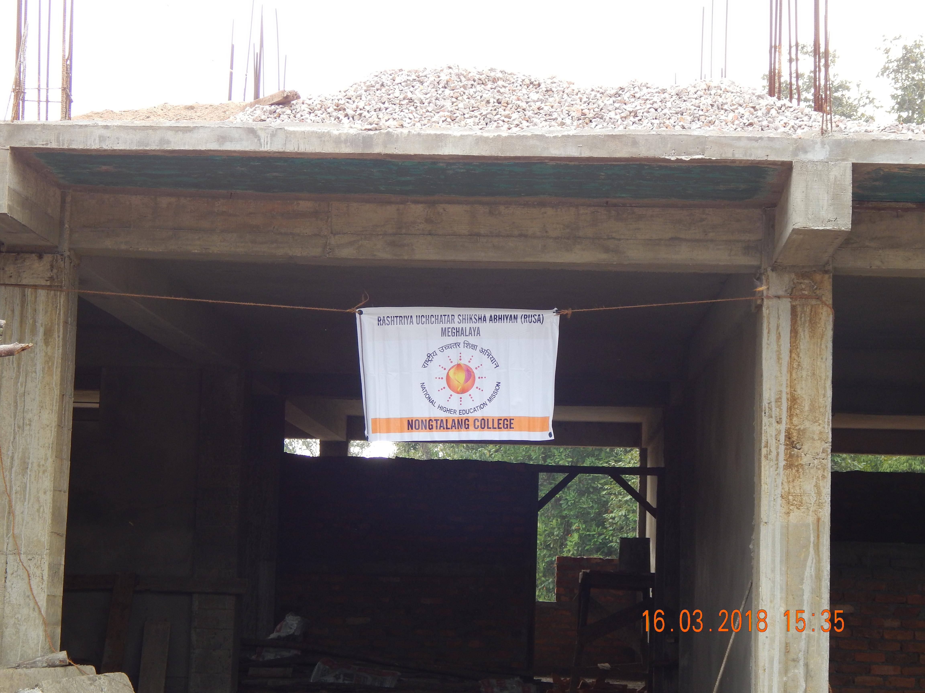
Renovation & up-gradation of Classroom on 1 floor of Existing classroom building Dt:16-03-2018

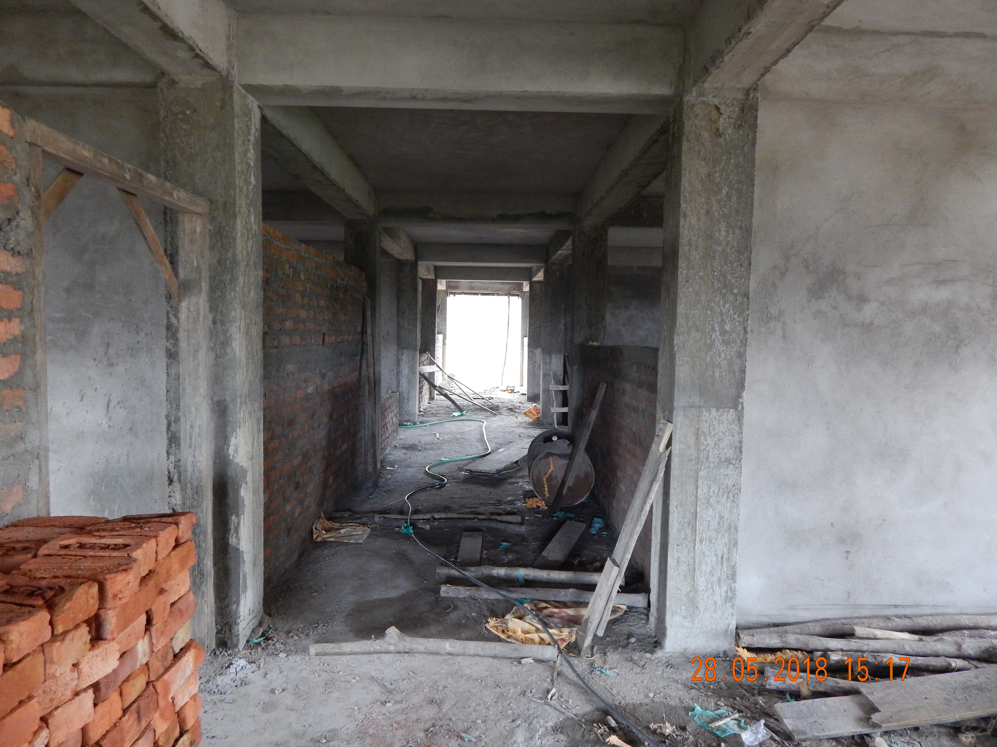
Plastering of Wall Dt:28-05-2018
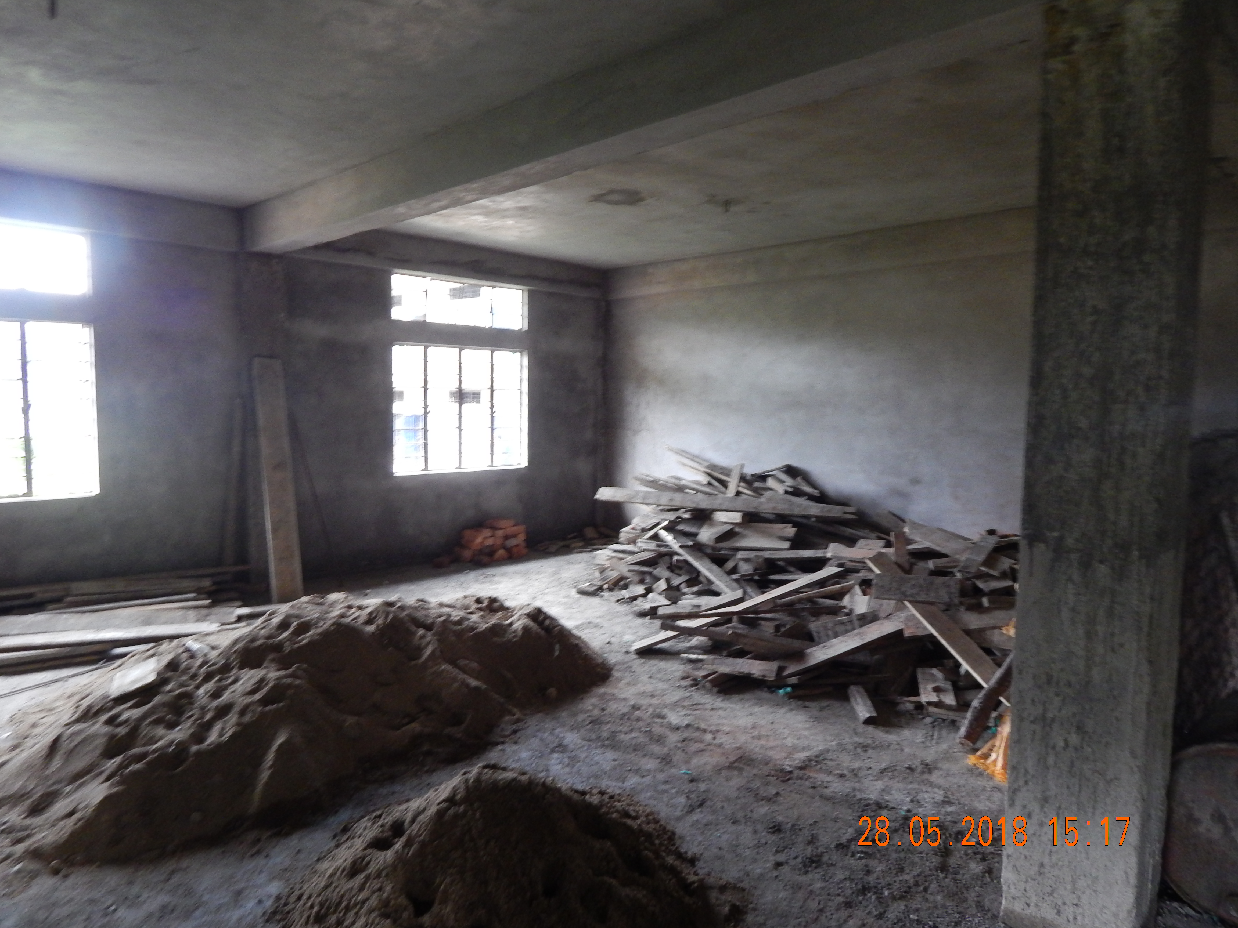
Plastering of Wall Dt:28-05-2018

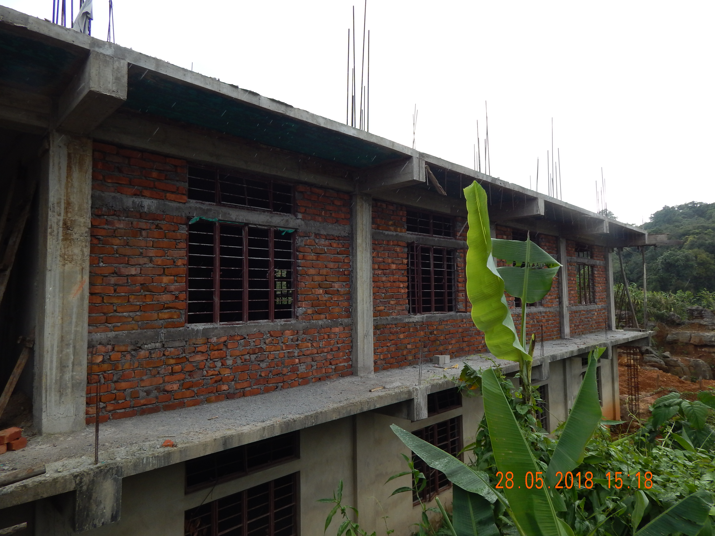
Renovation & up-gradation of Classroom on 1 floor of Existing classroom building Dt:28-05-2018
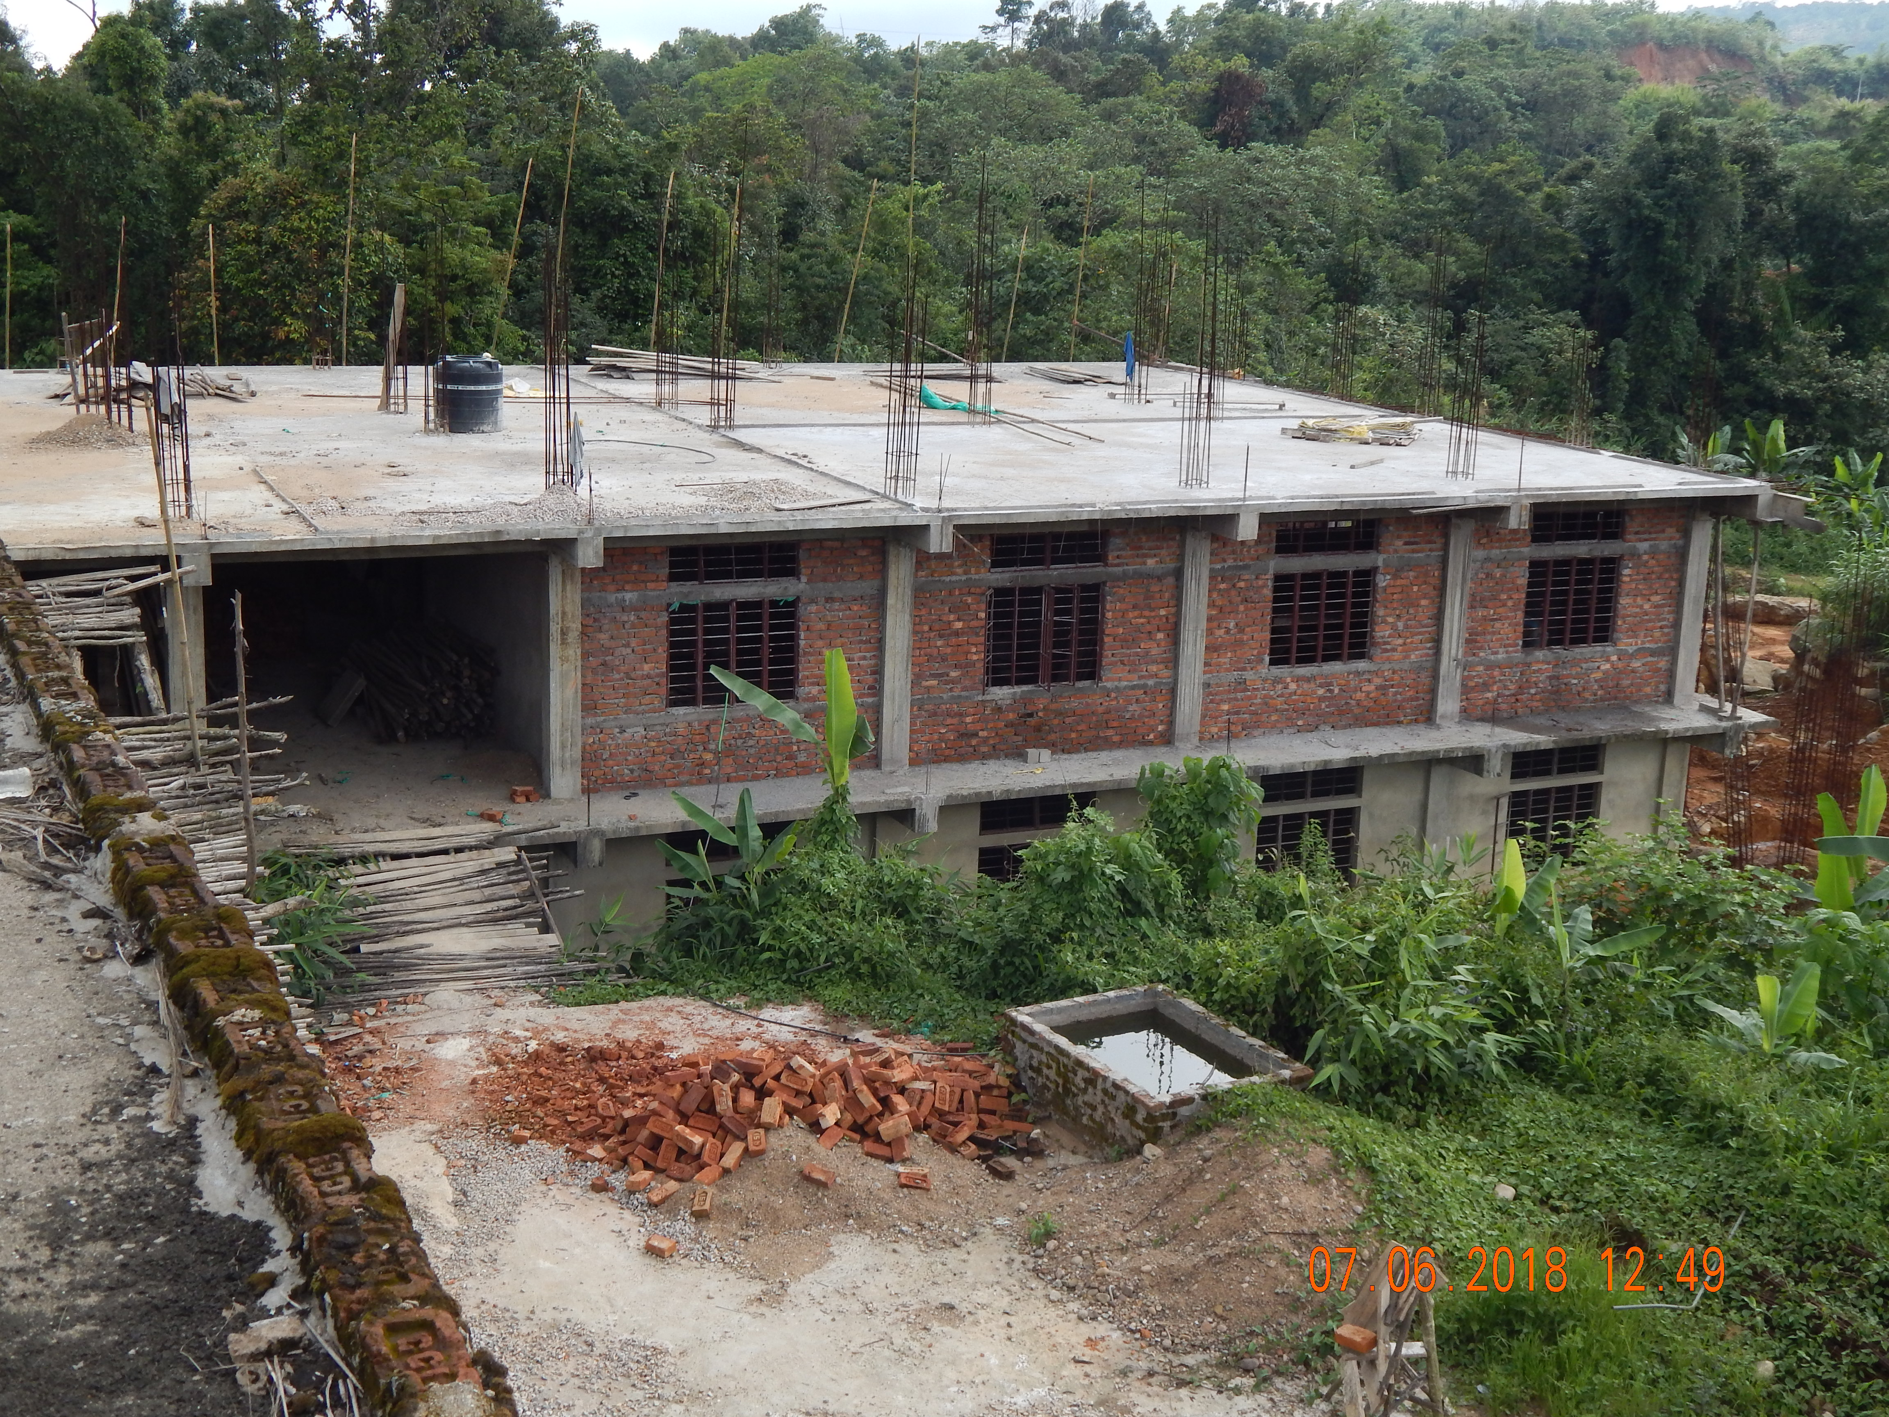
Renovation & up-gradation of Classroom on 1 floor of Existing classroom building Dt:07-06-2018

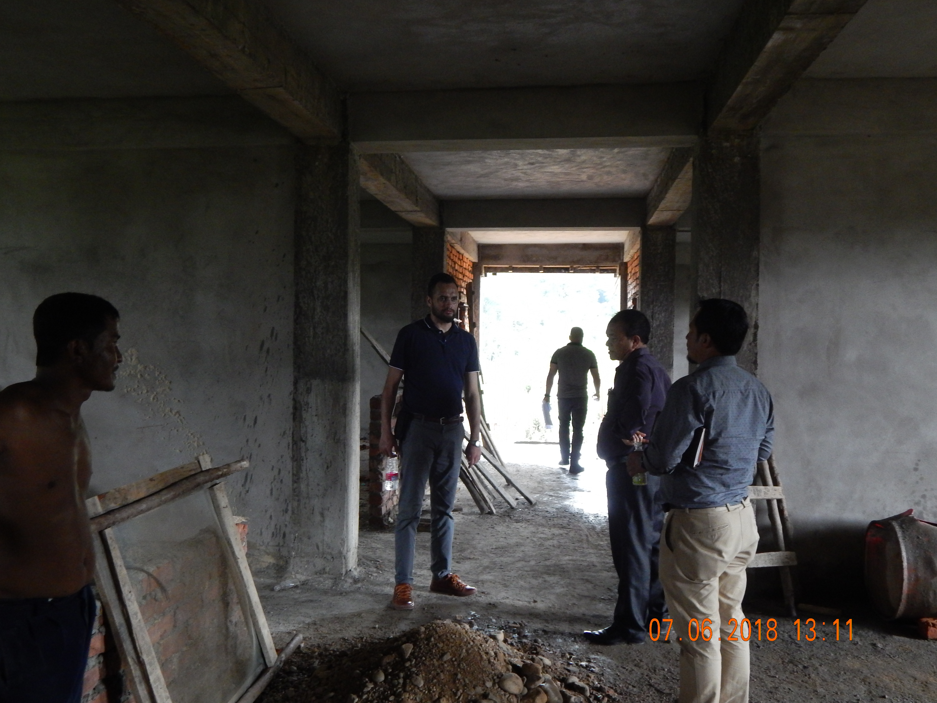
Inspection Team by RUSA Official Dt:07-06-2018
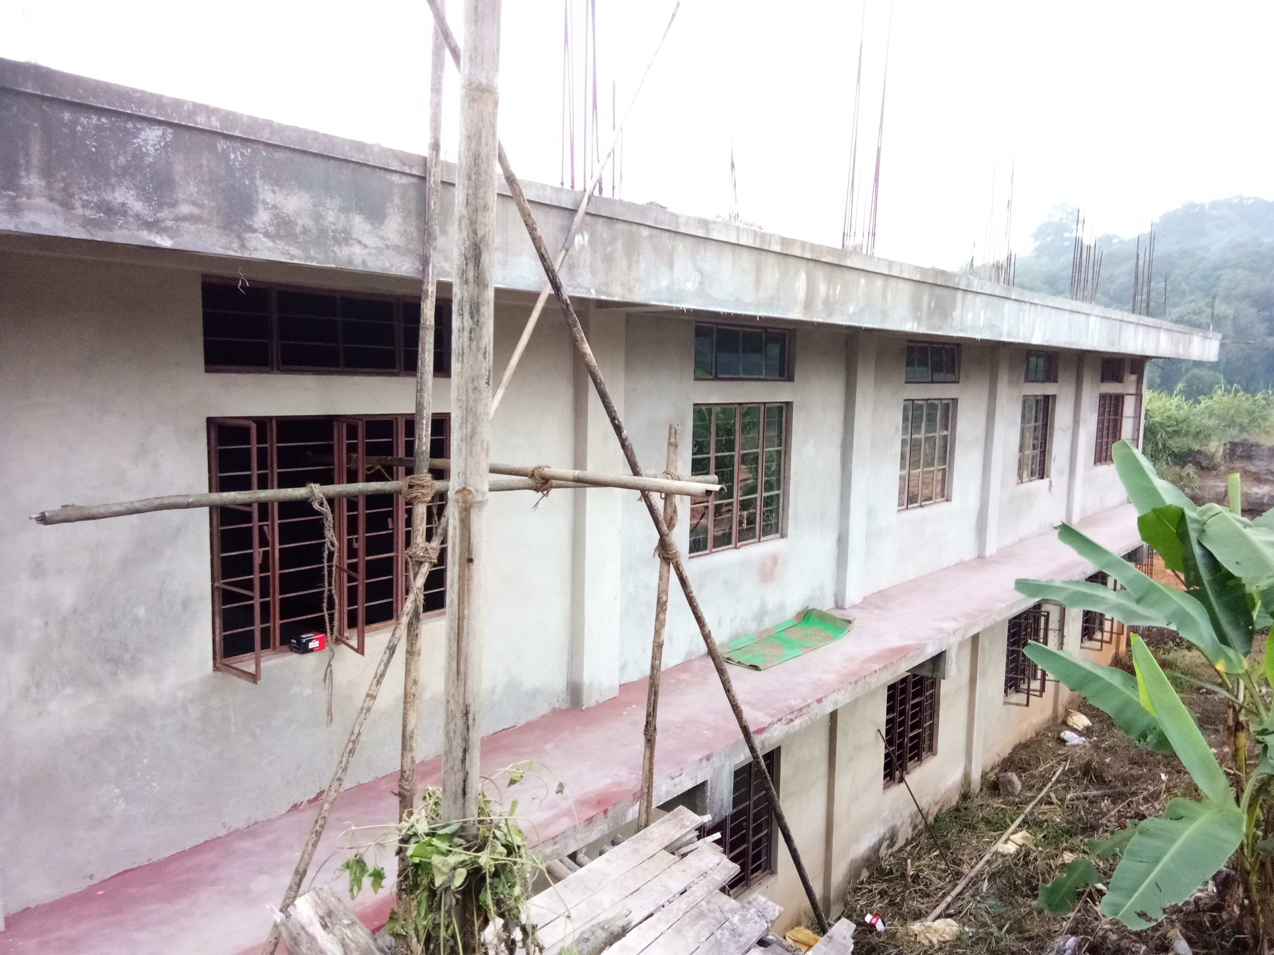
Renovation & up-gradation of Classroom after plastering Dt:08-10-2018

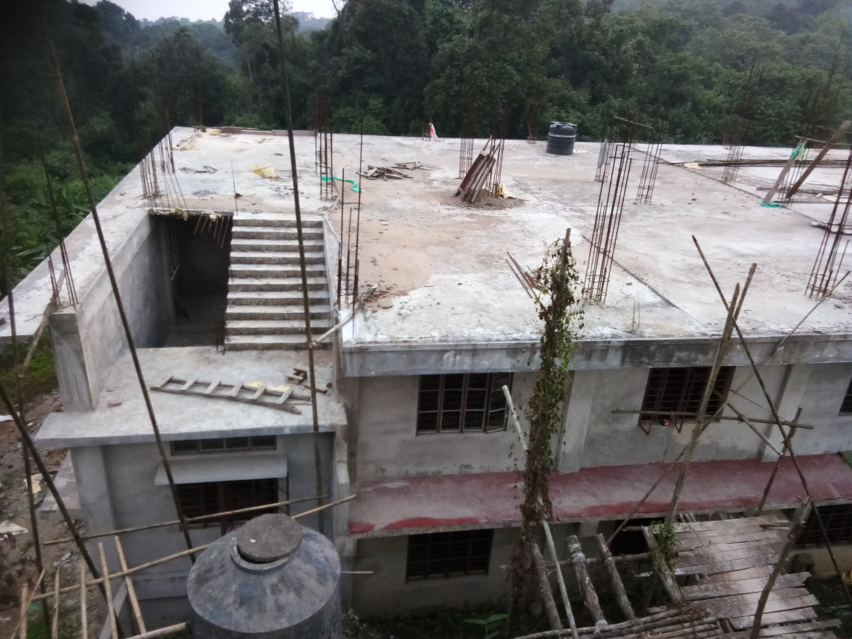
Renovation & up-gradation of Classroom after plastering Dt:08-10-2018

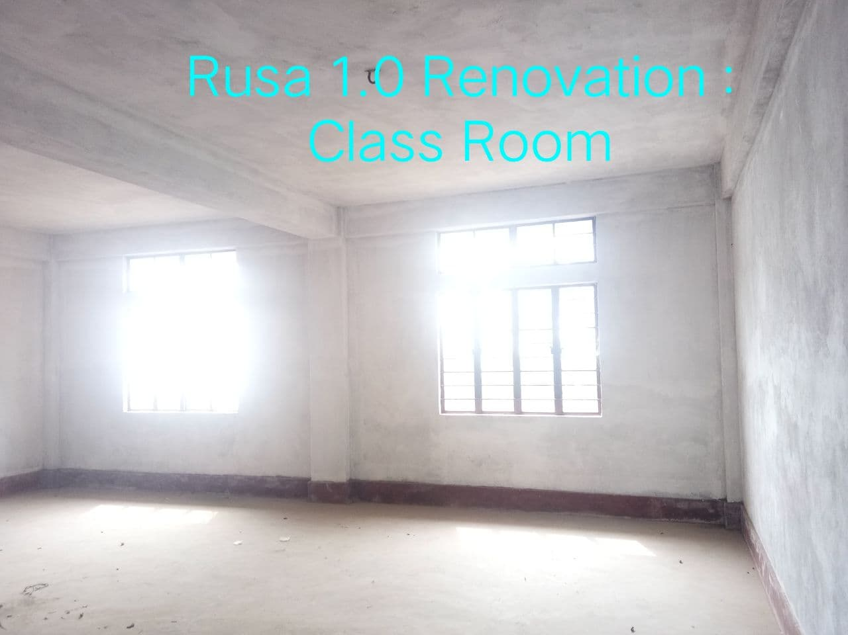
Classroom

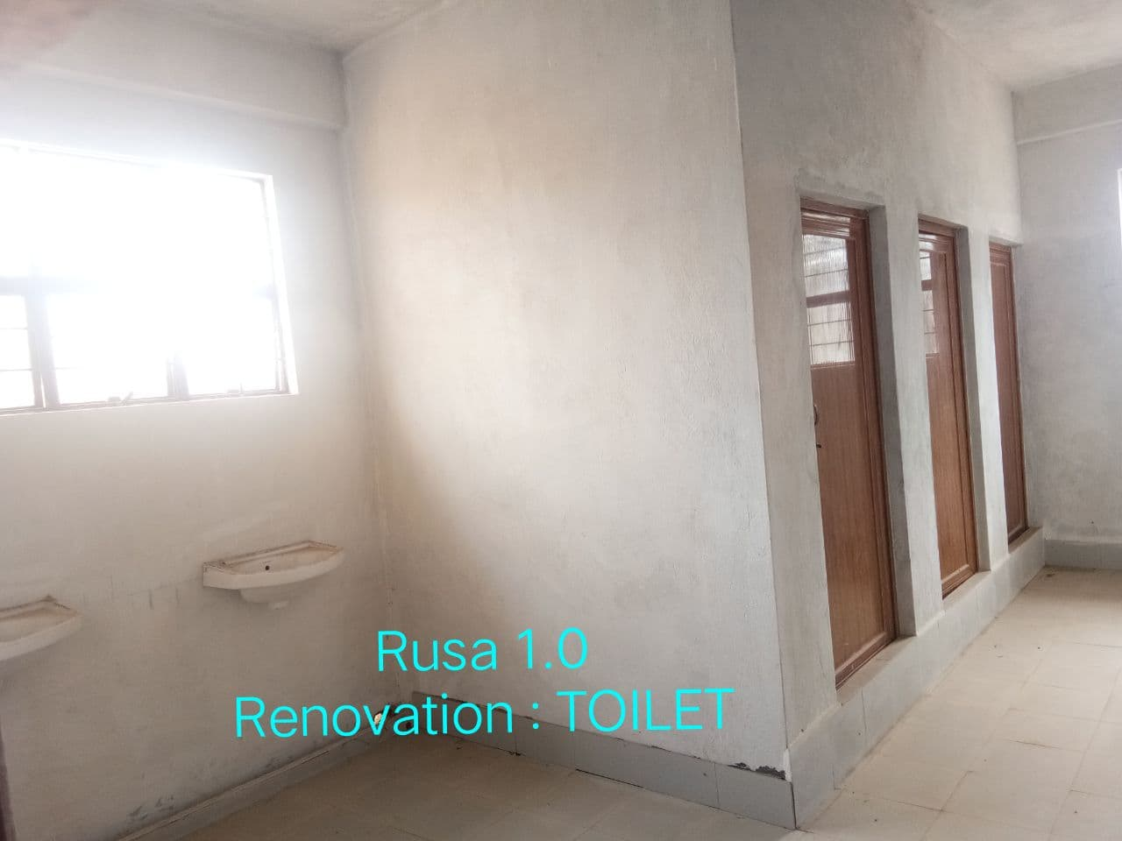
Toilet
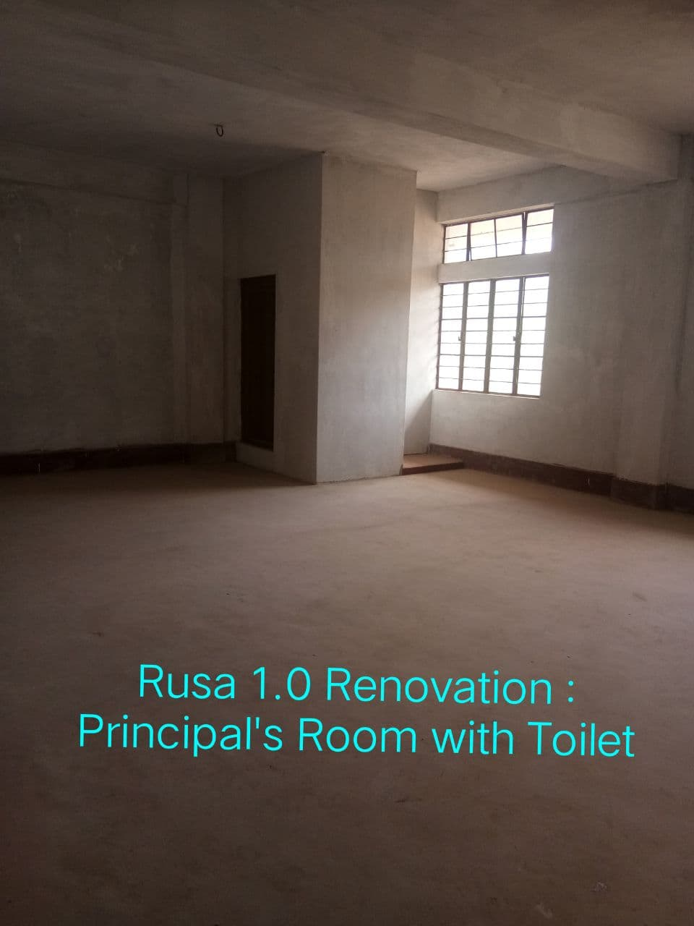
Principal room Toilet

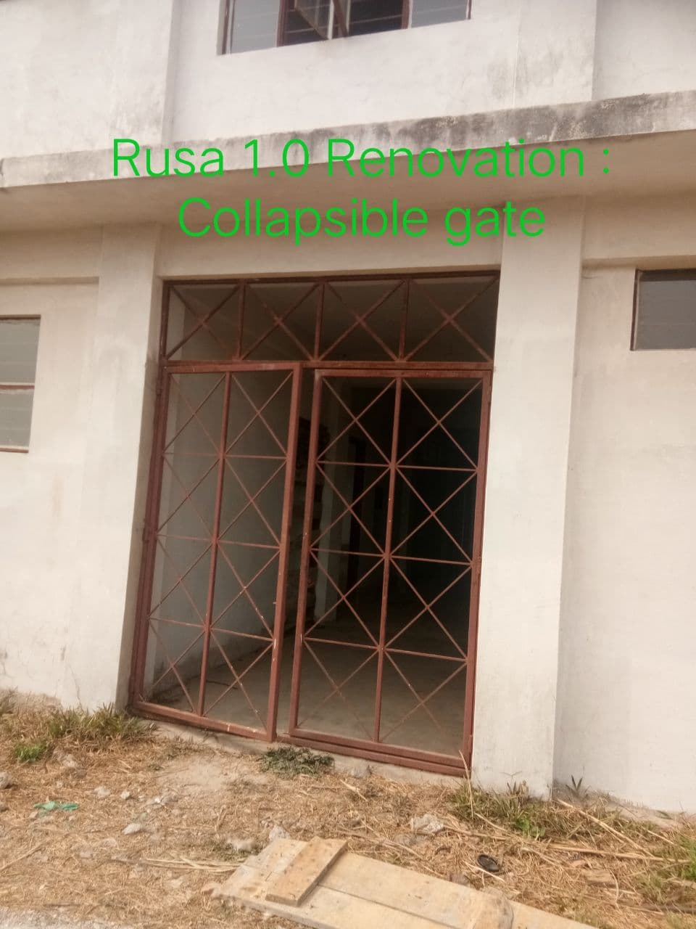
Back side of Classroom

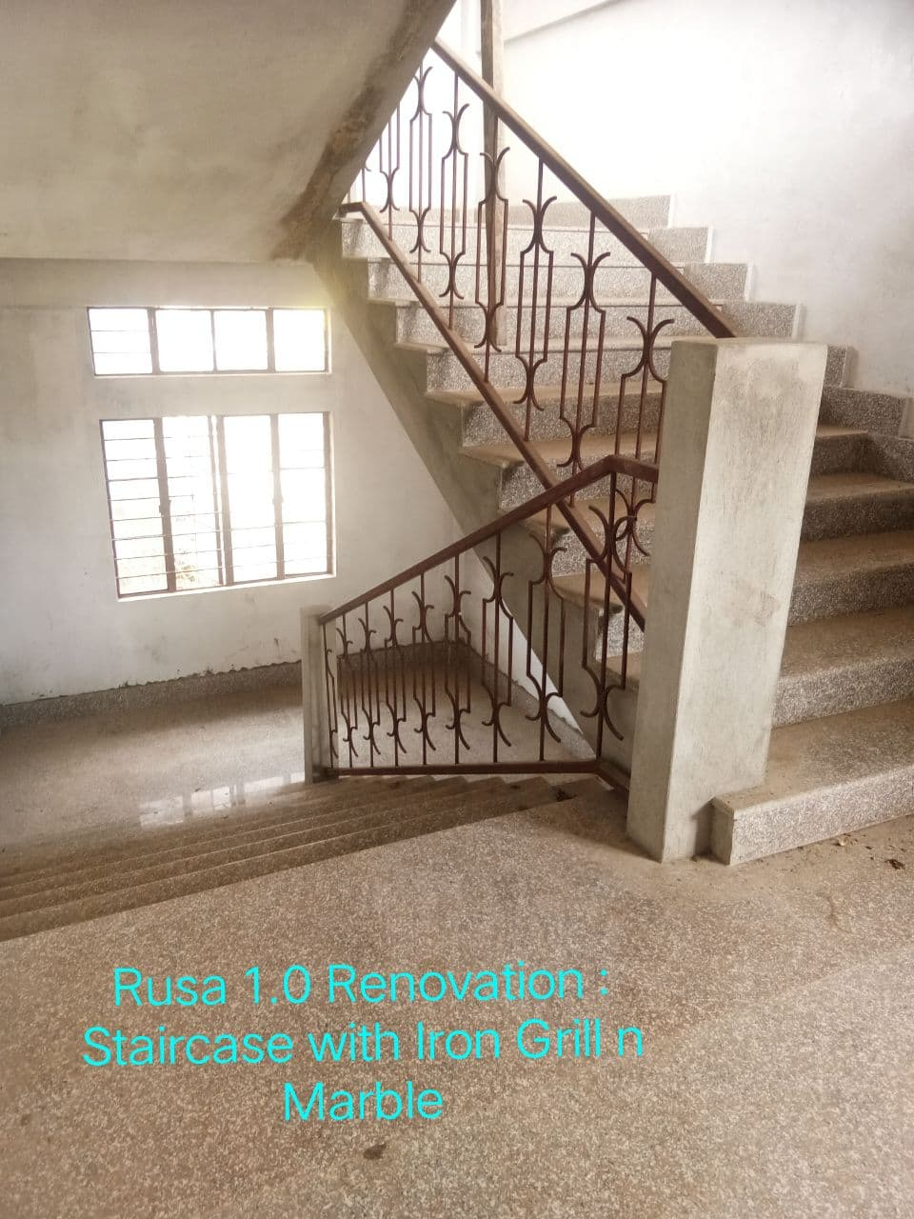
Staircase with iron grill and marble

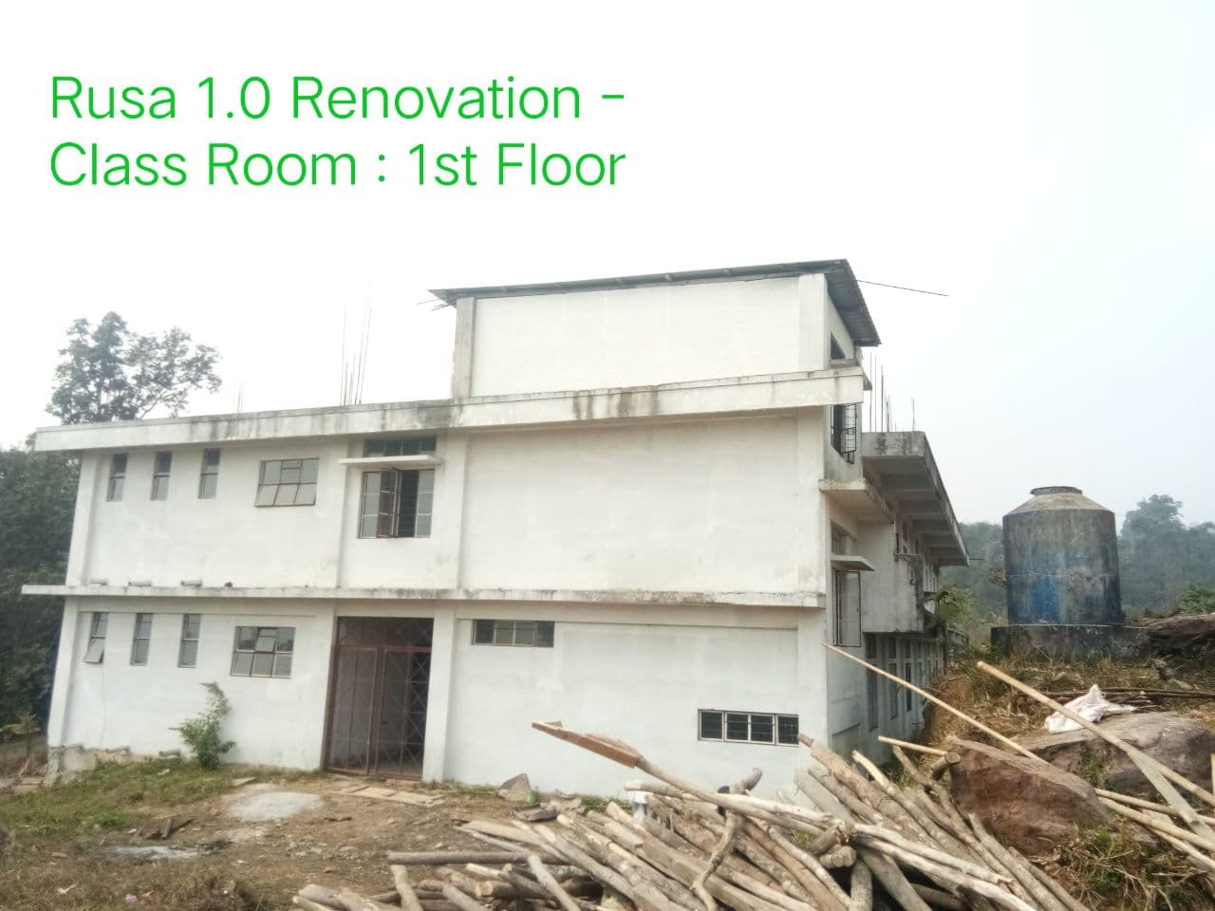

Renovation & up-gradation of Classroom 1st floor.

