Nongtalang College, Nongtalang

Procurement of IT Equipments Under RUSA 1.0

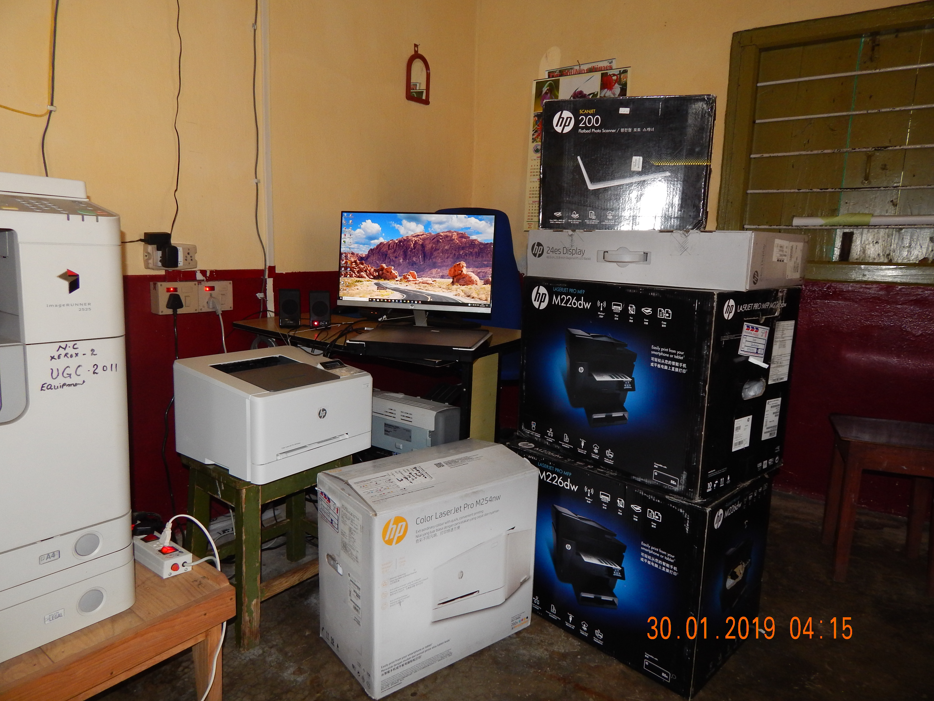
1No. Desktop PC, 2Nos. of HP LaserJet Monochrome Printer, 1No. HPLaserJet Colour Printer & 1No. HP ScanJet 200 (Scanner)
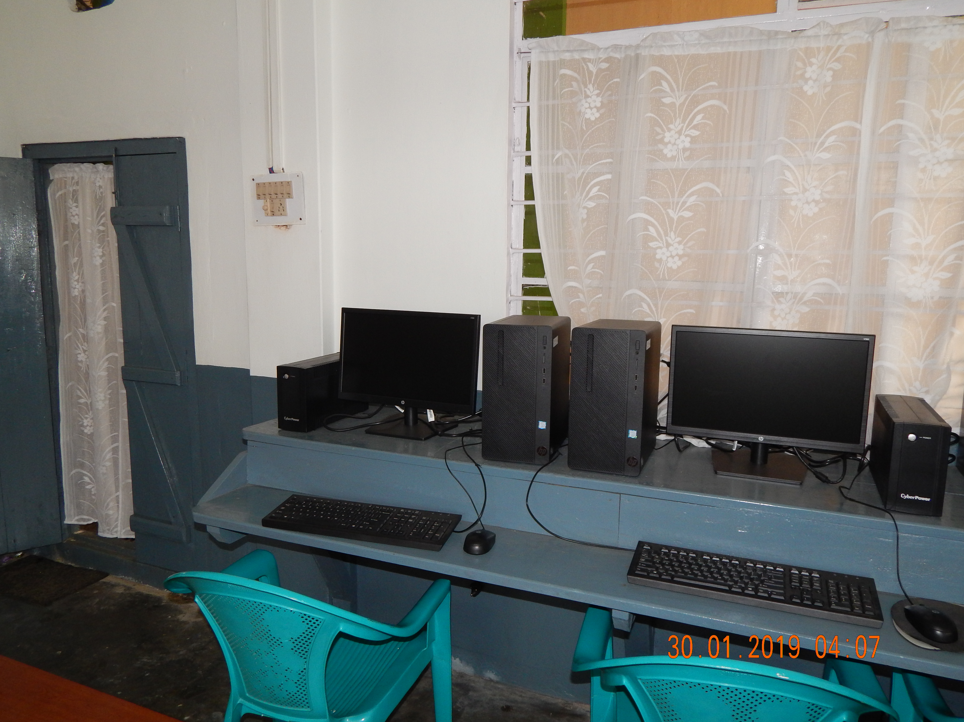
5Nos. HP Desktop PC at Computer Lab

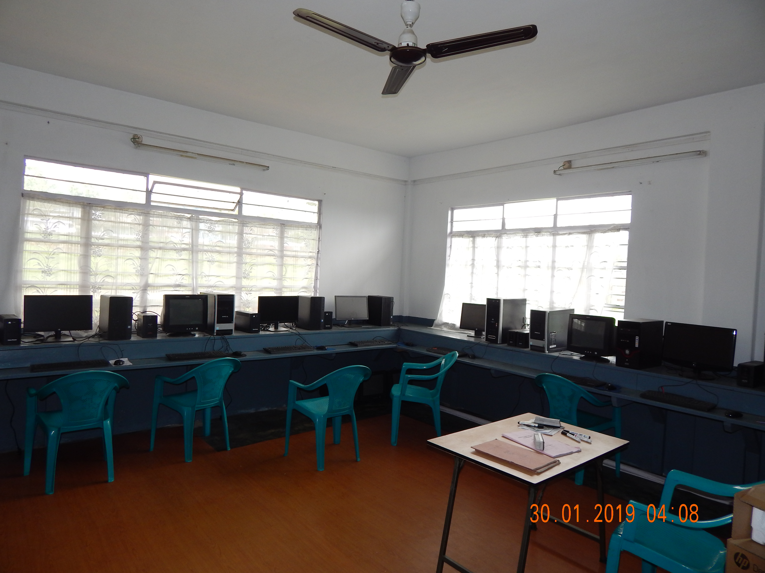
5Nos. HP Desktop PC at Computer Lab
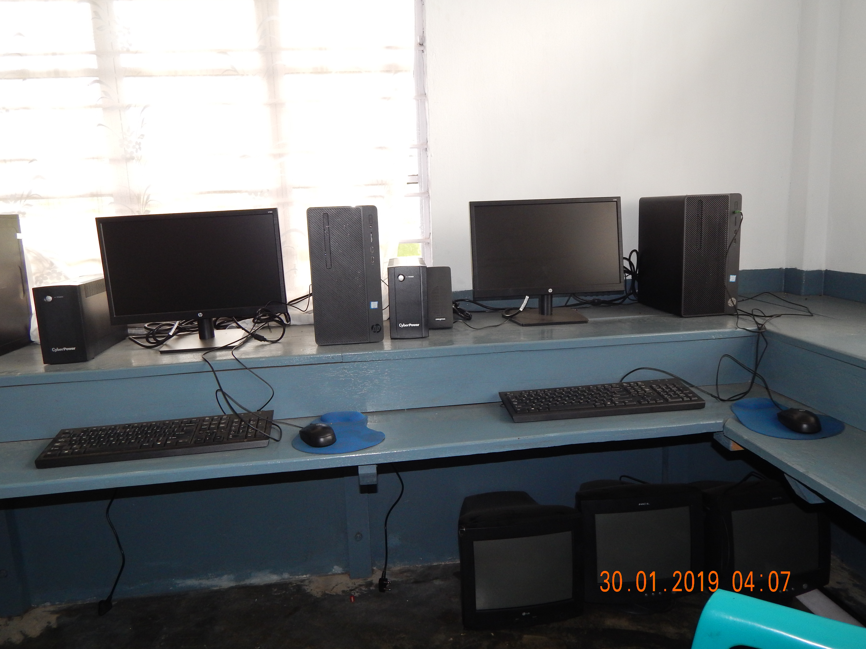
5Nos. HP Desktop PC at Computer Lab

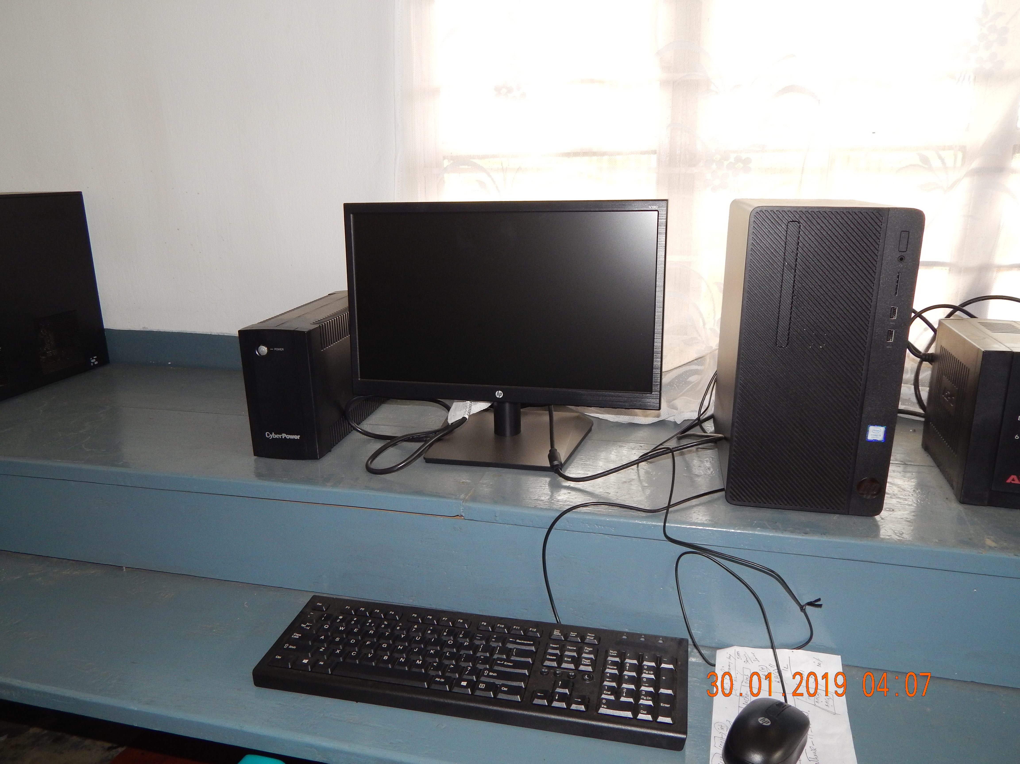
5Nos. HP Desktop PC at Computer Lab
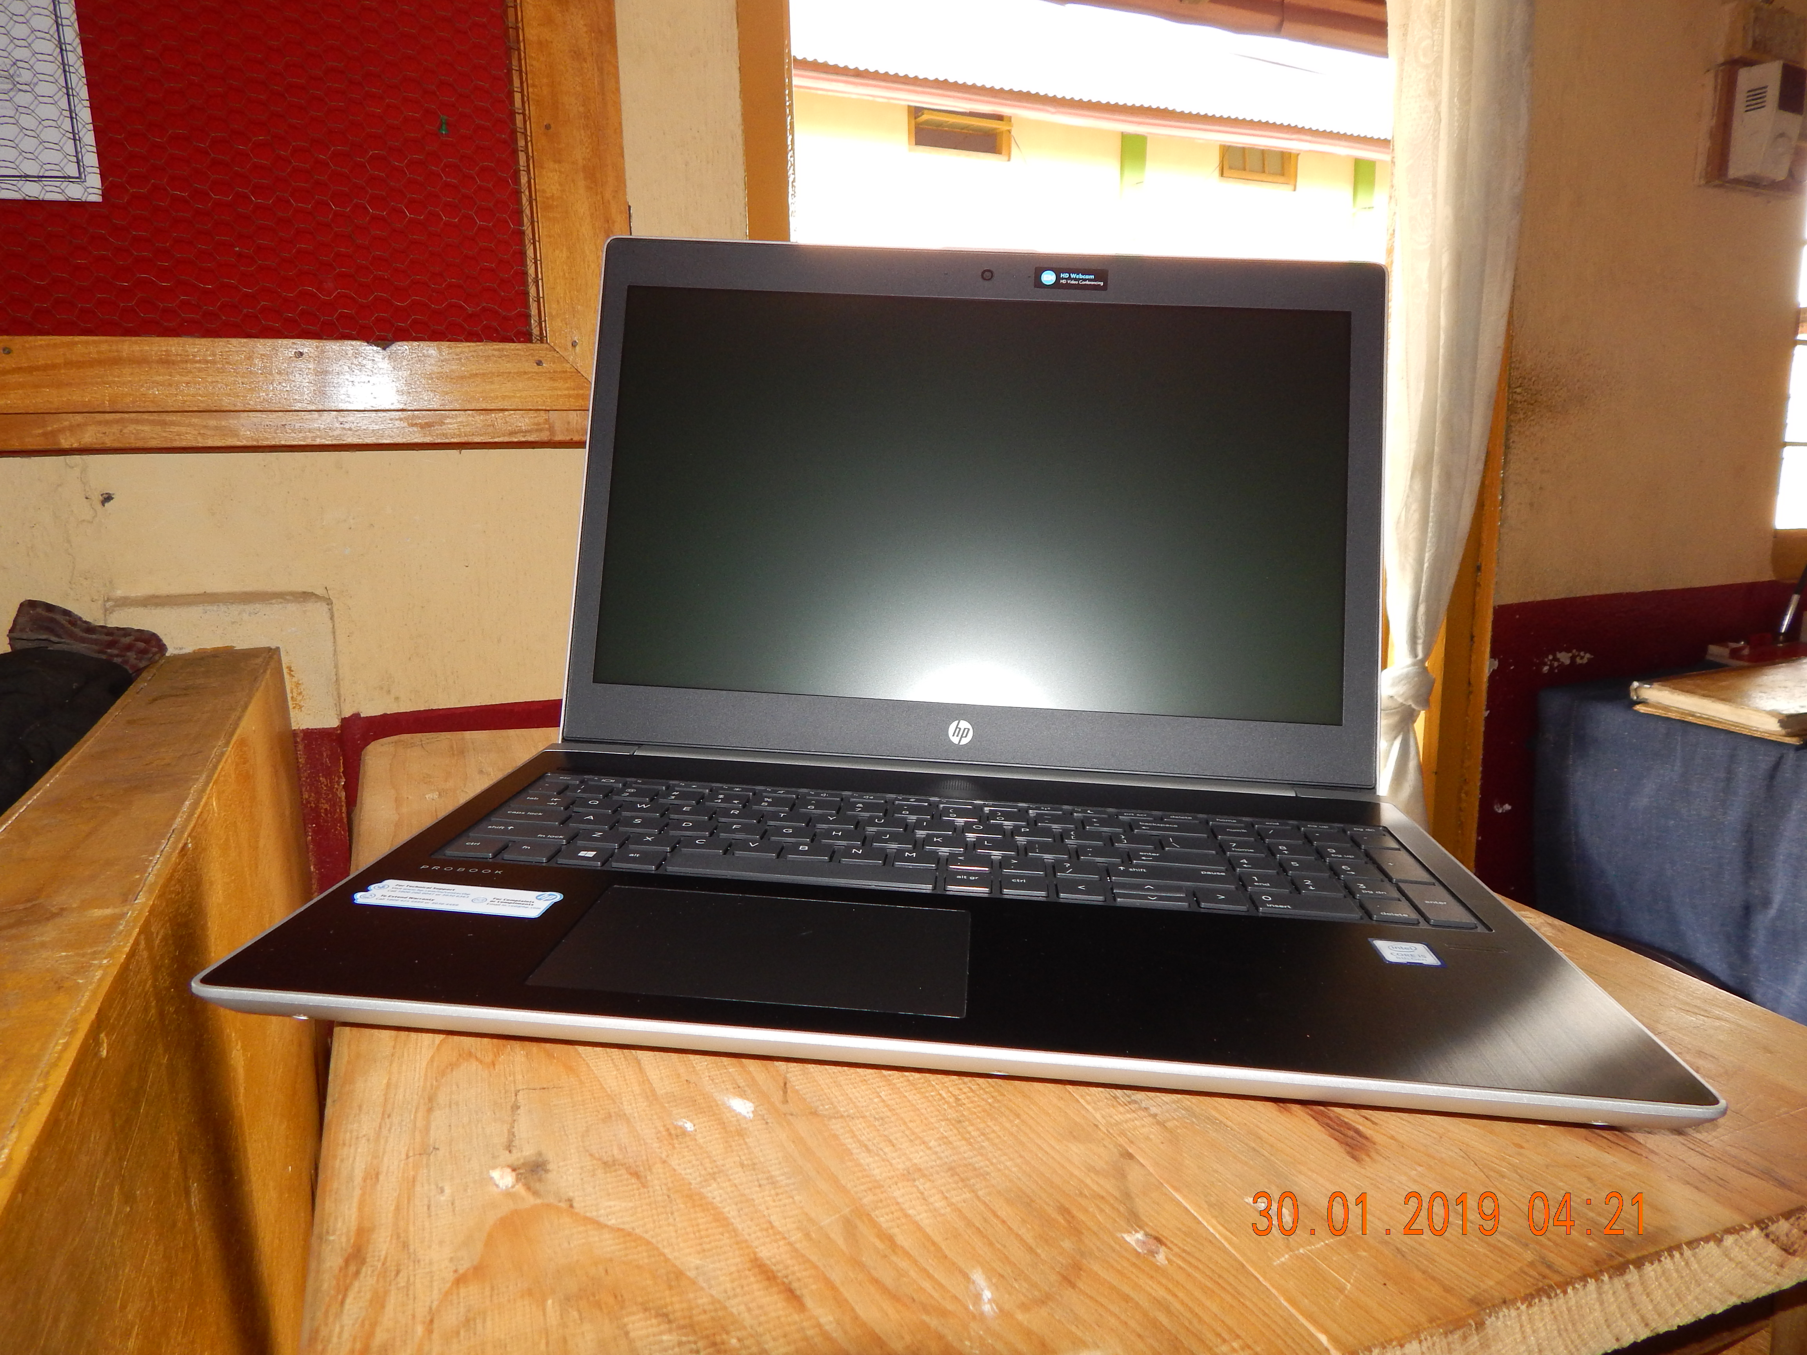
1No. Laptop

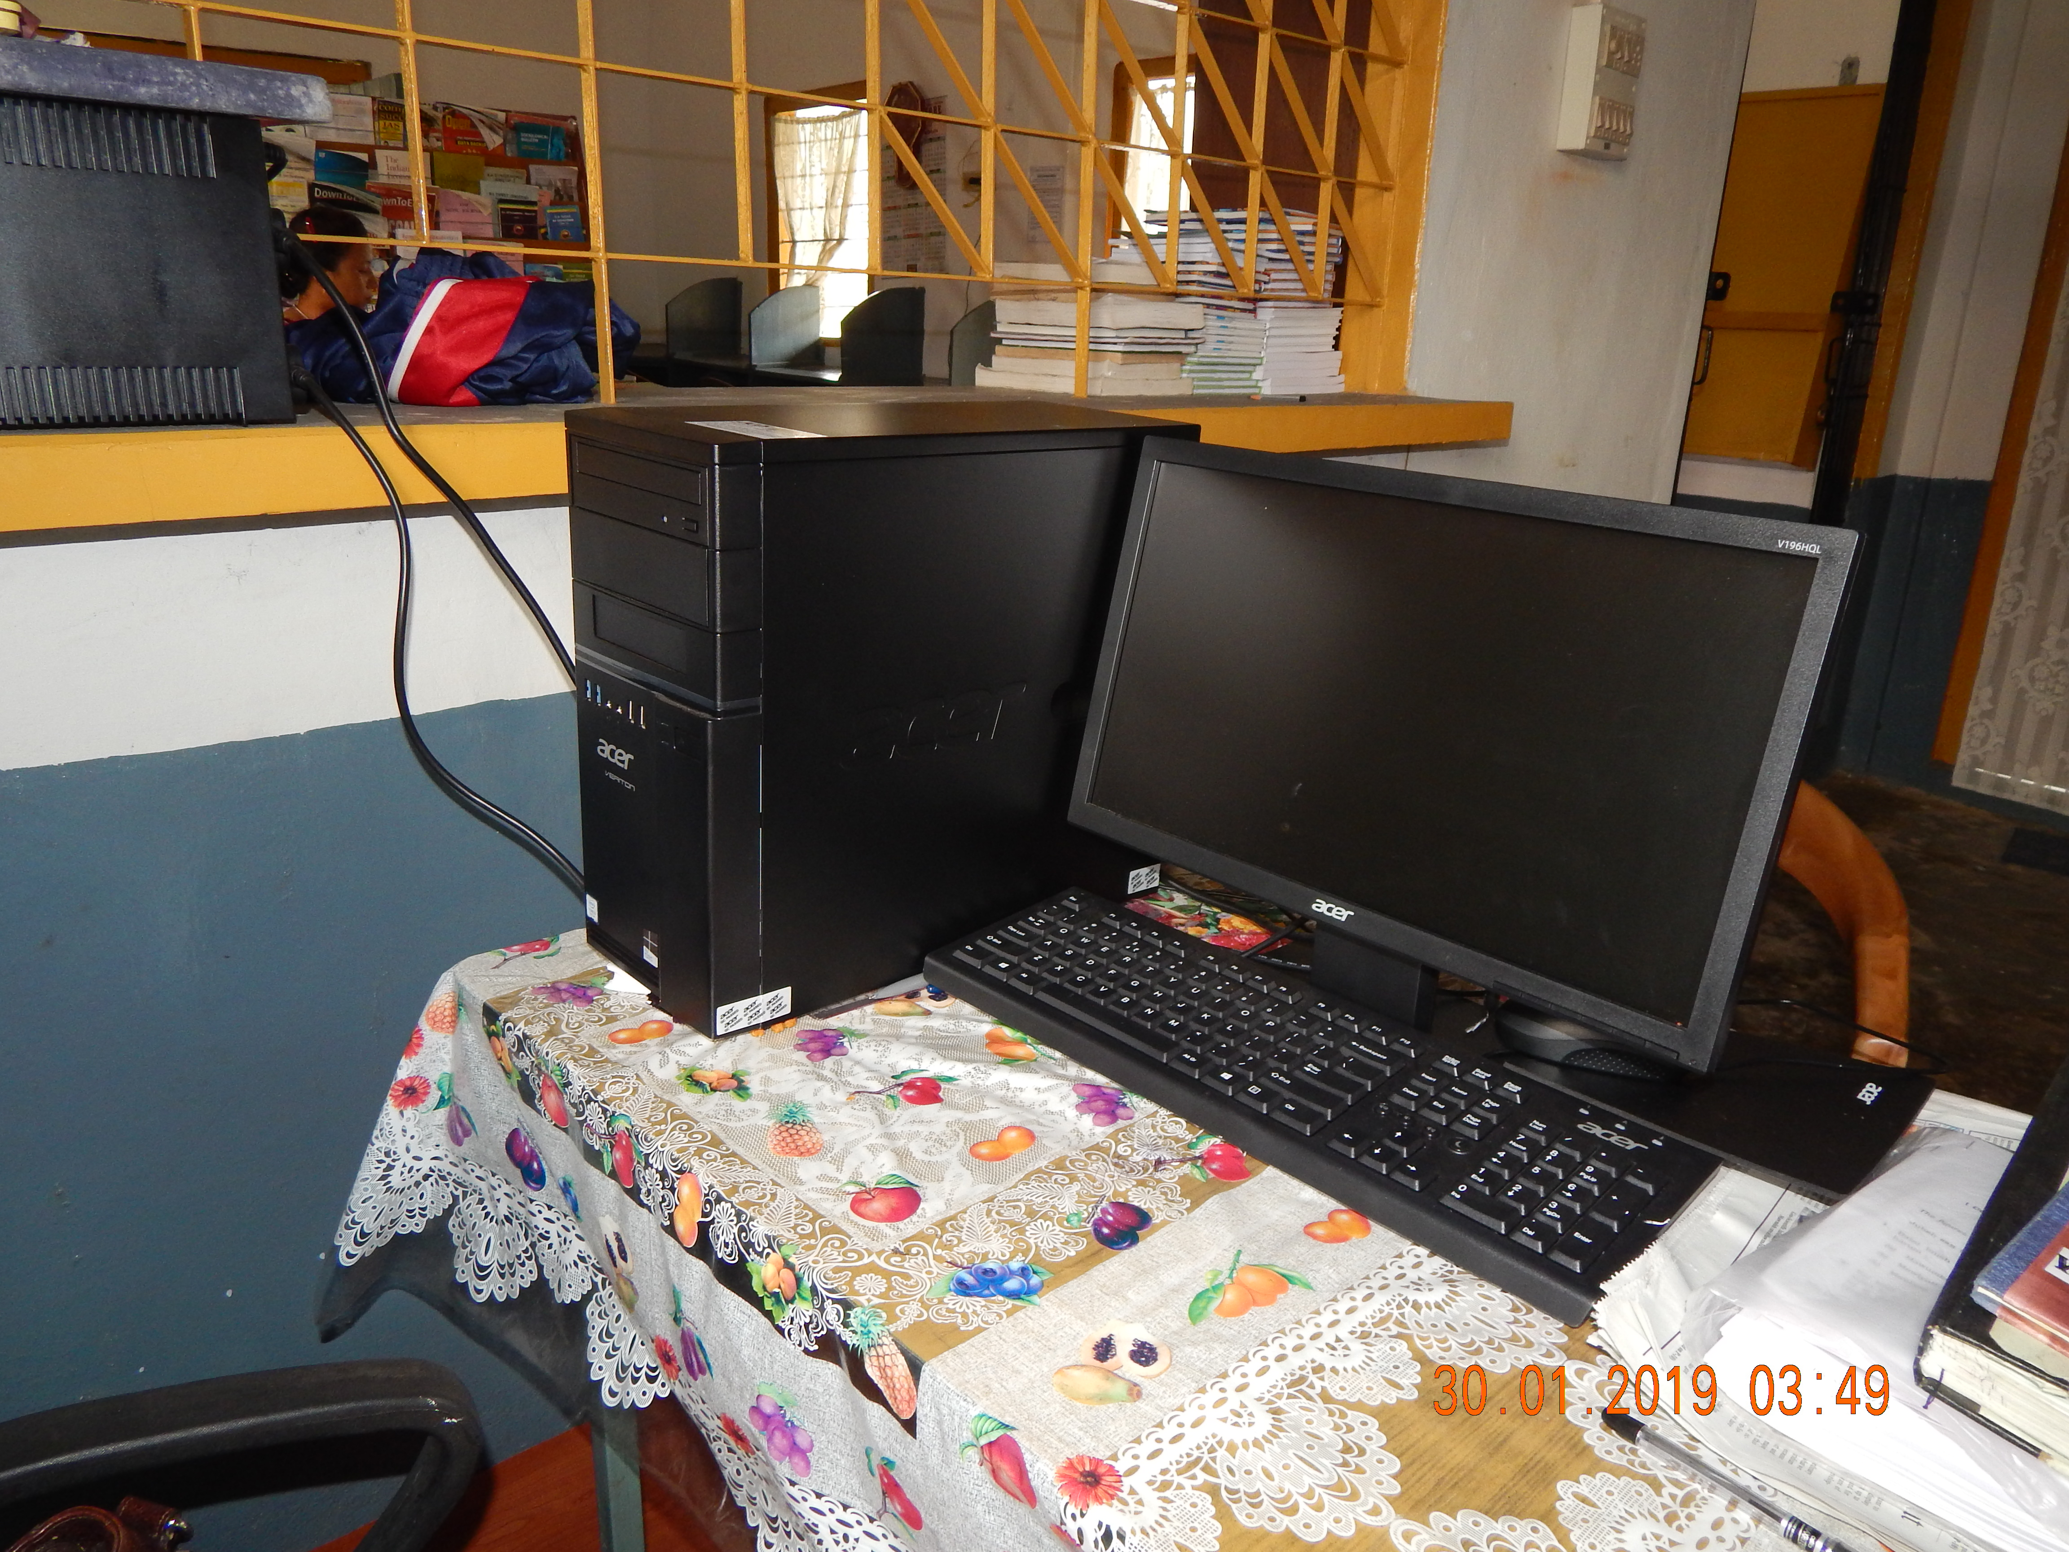
1No. Desktop PC in Library

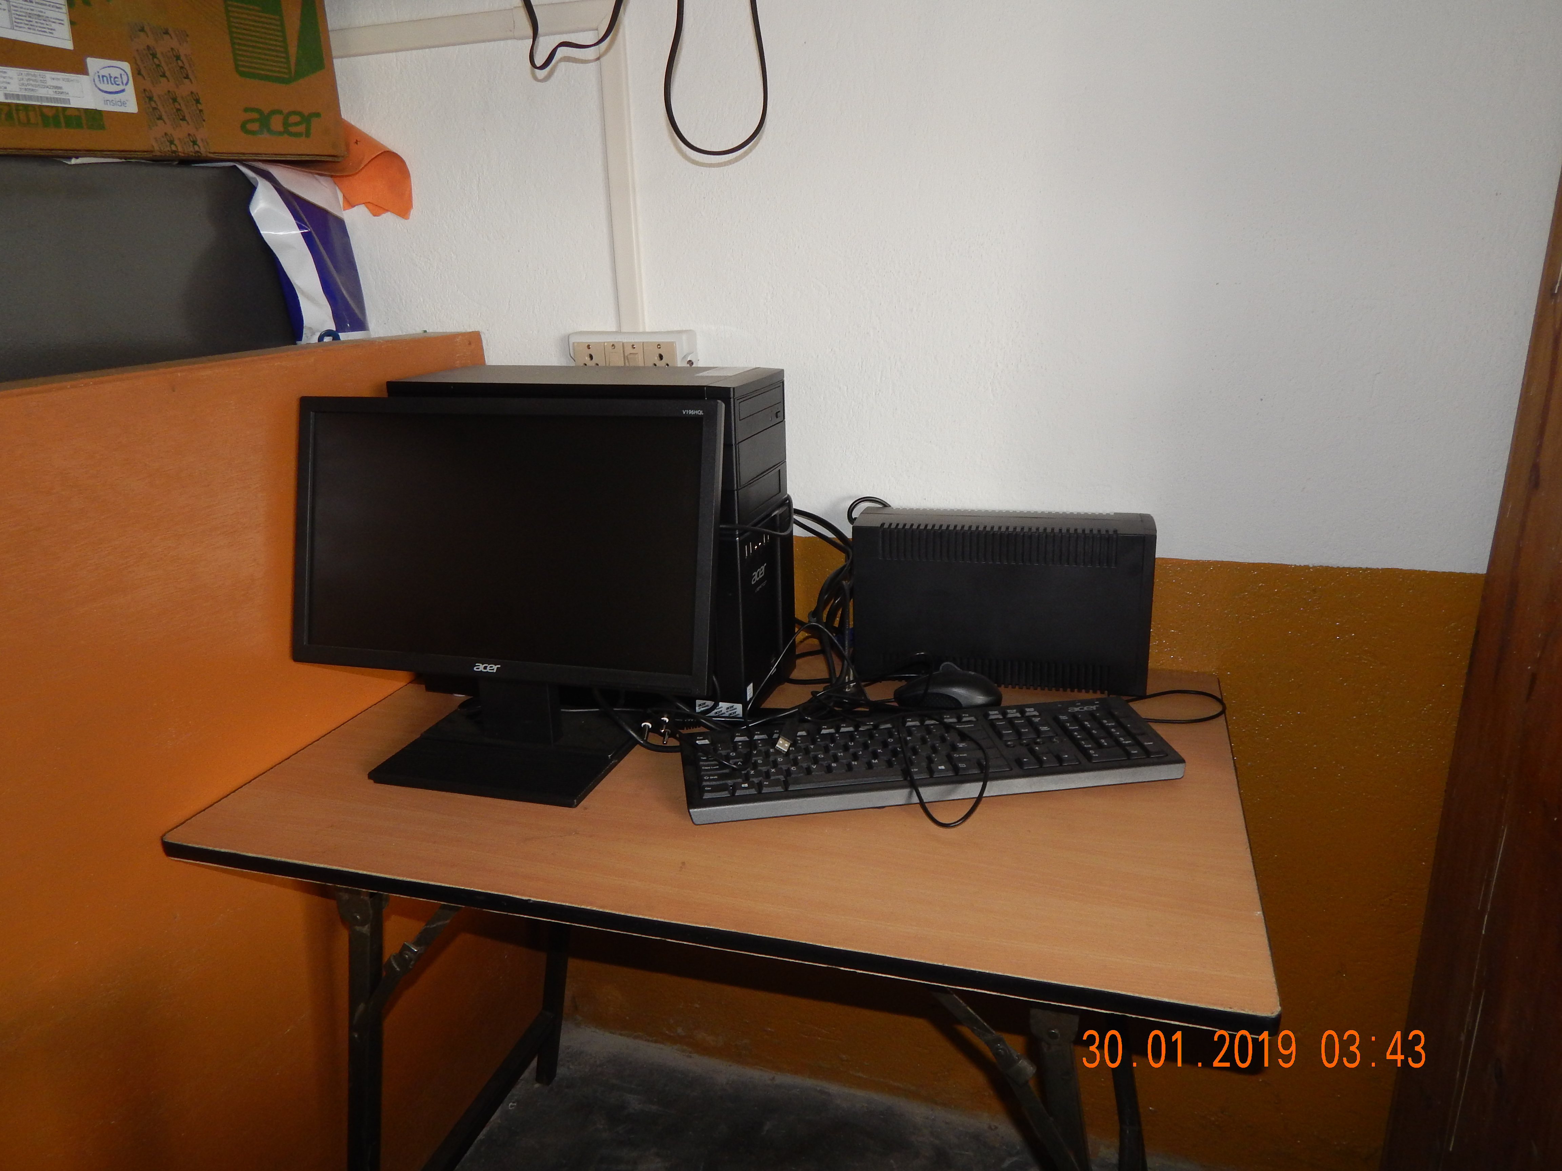
1No. Desktop PC - Department of Khasi

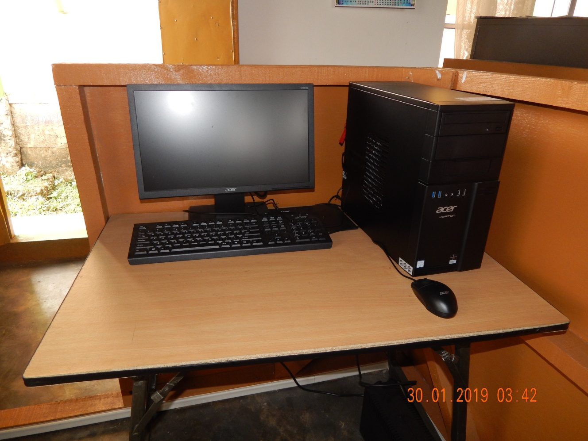
1No. Desktop PC - Department of Political Science

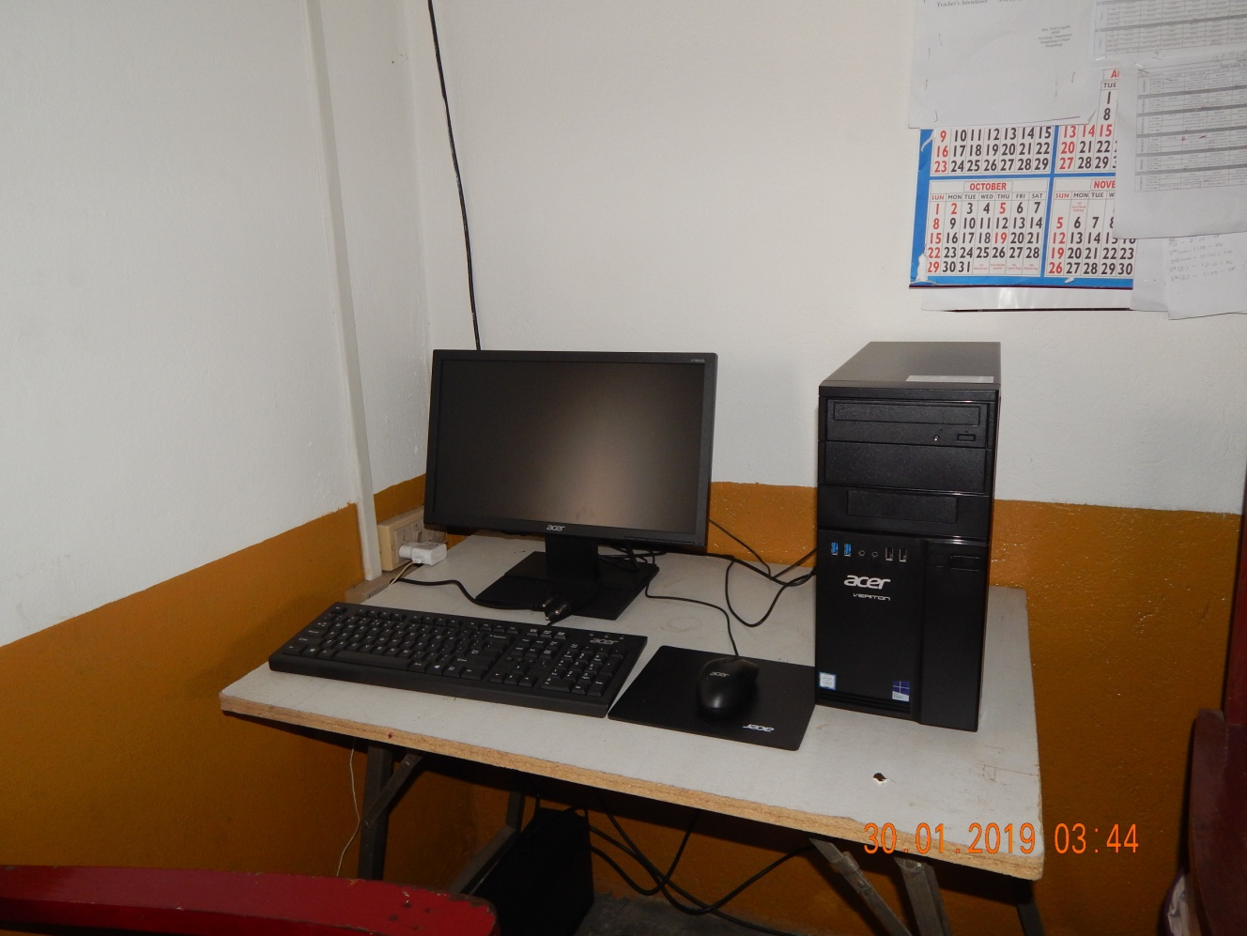
1No. Desktop PC - Department of Sociology

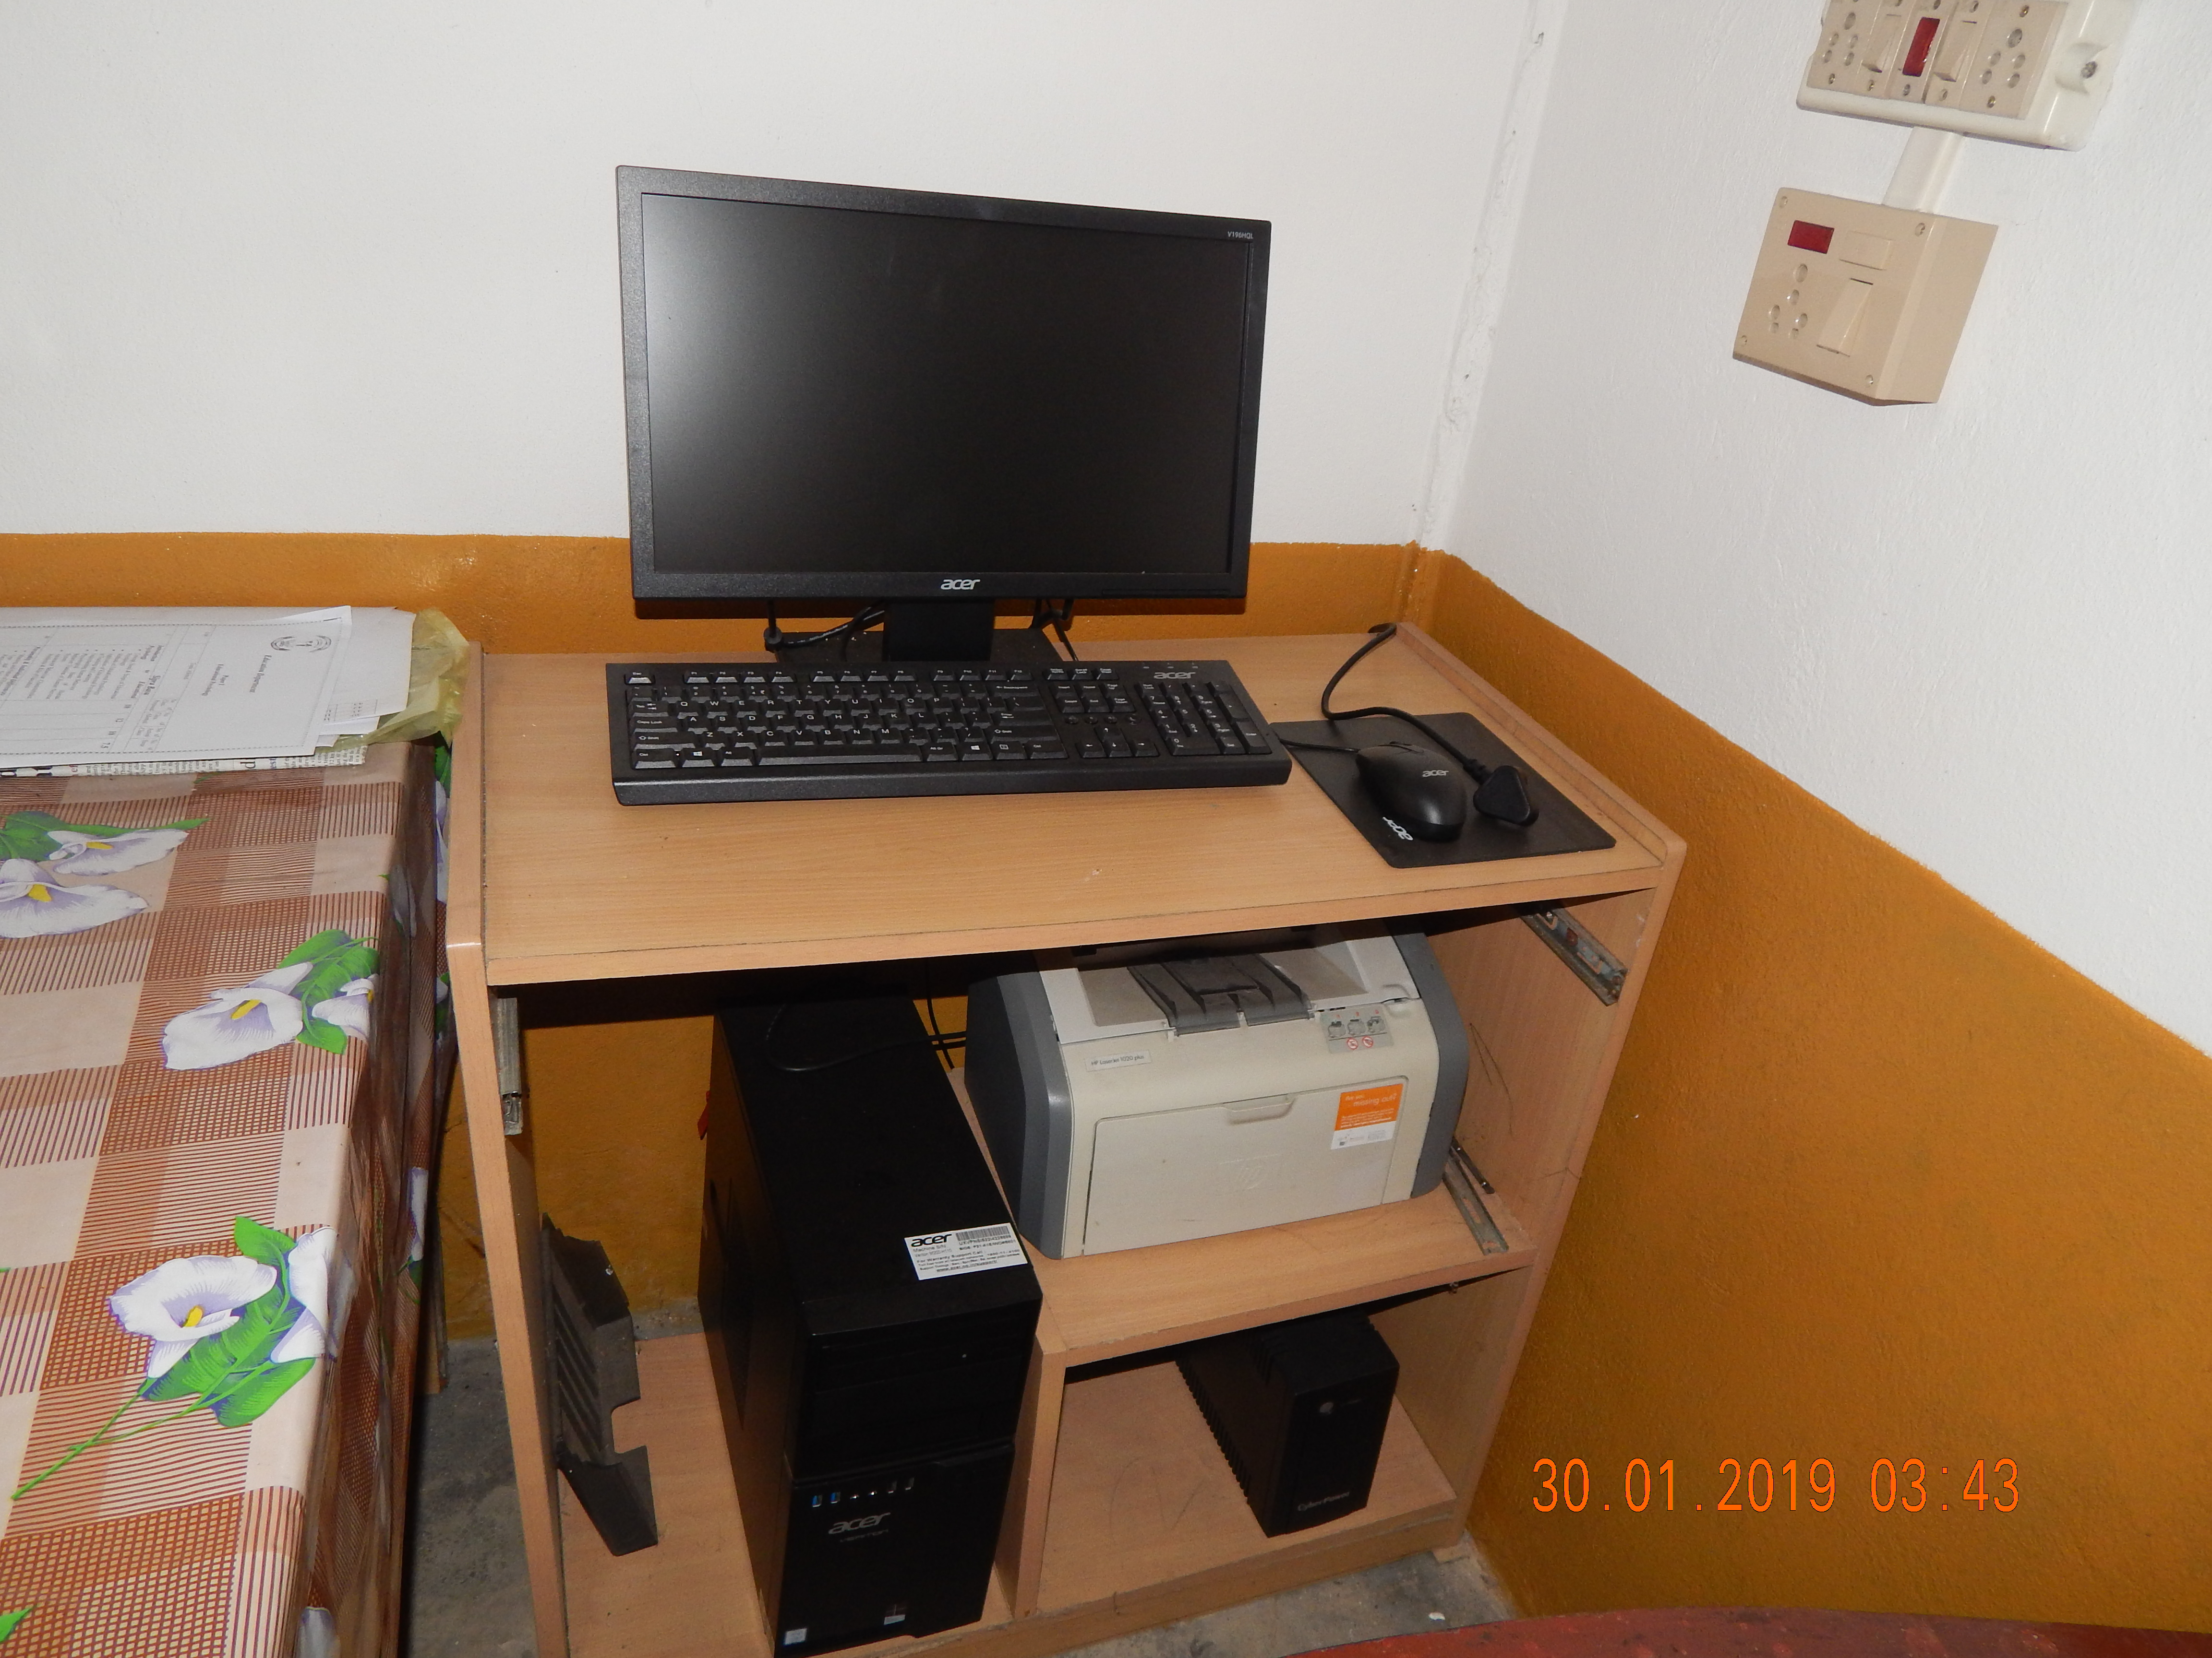
1No. Desktop PC - Department of Education
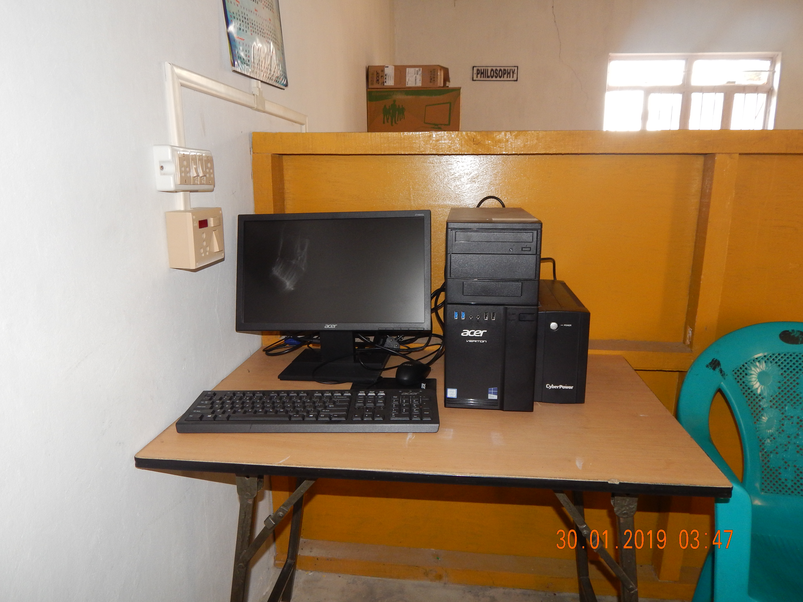
1No. Desktop PC - Department of Economics

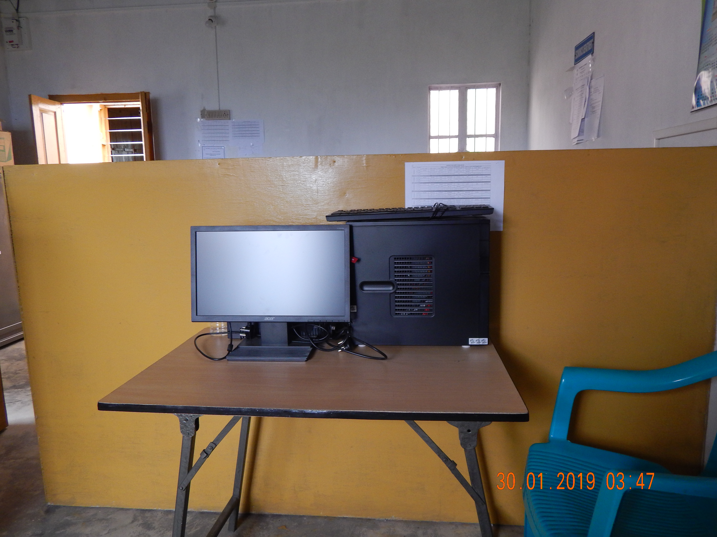
1No. Desktop PC - Department of Philosophy
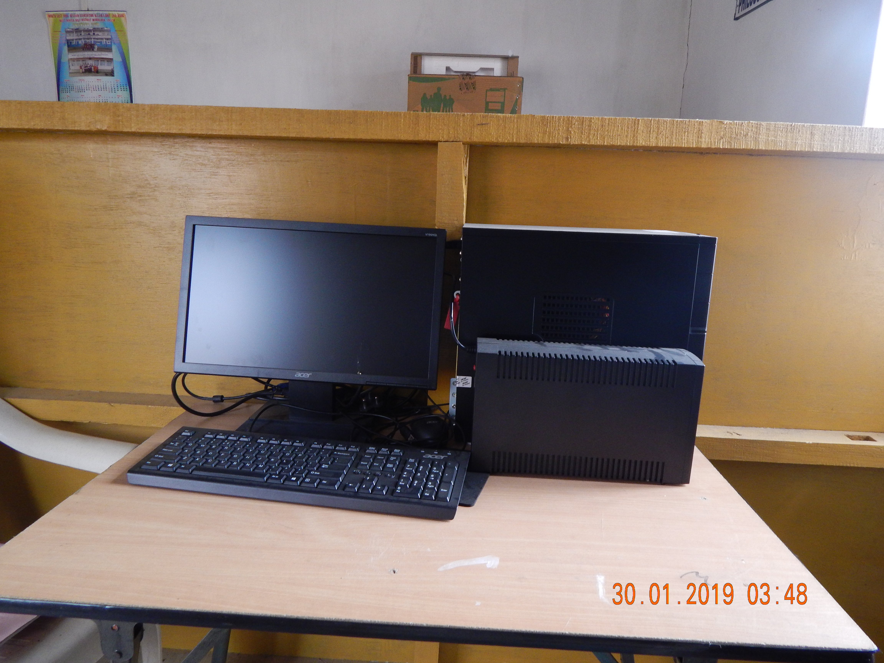
1No. Desktop PC - Department of English

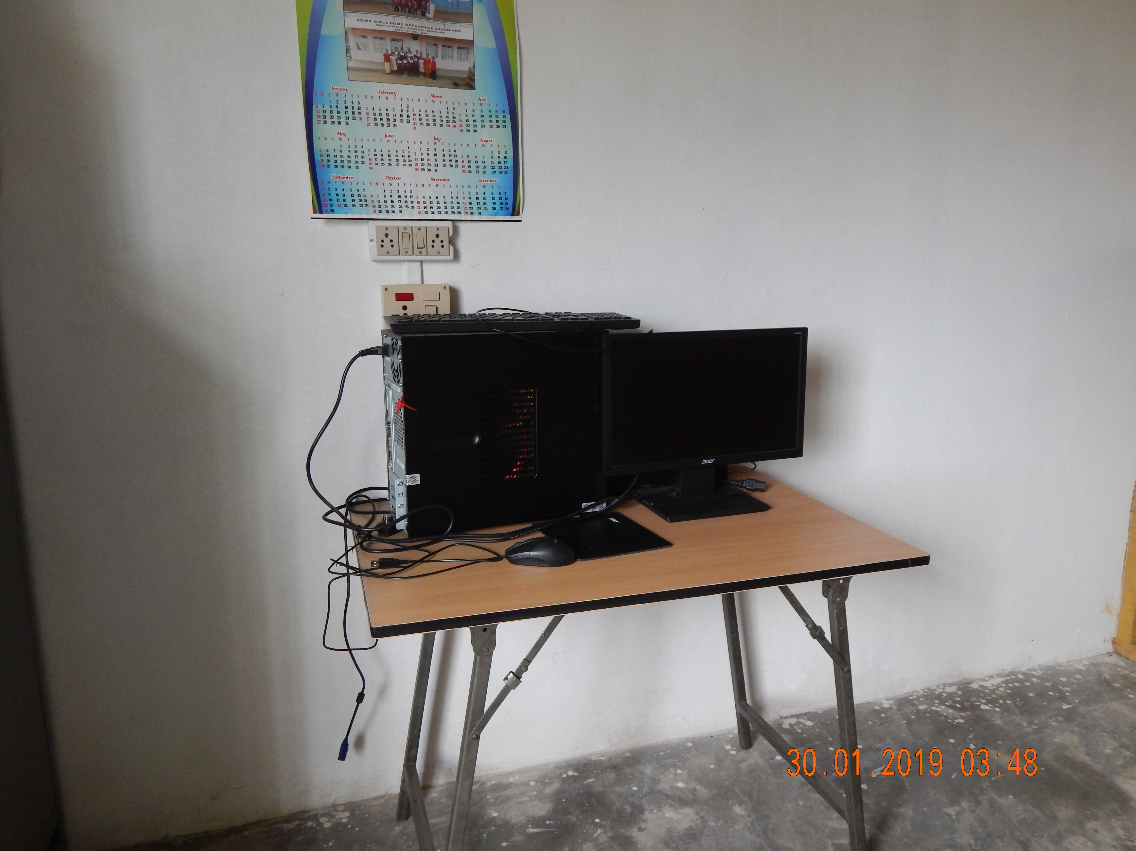
1No. Desktop PC - Department of Environment

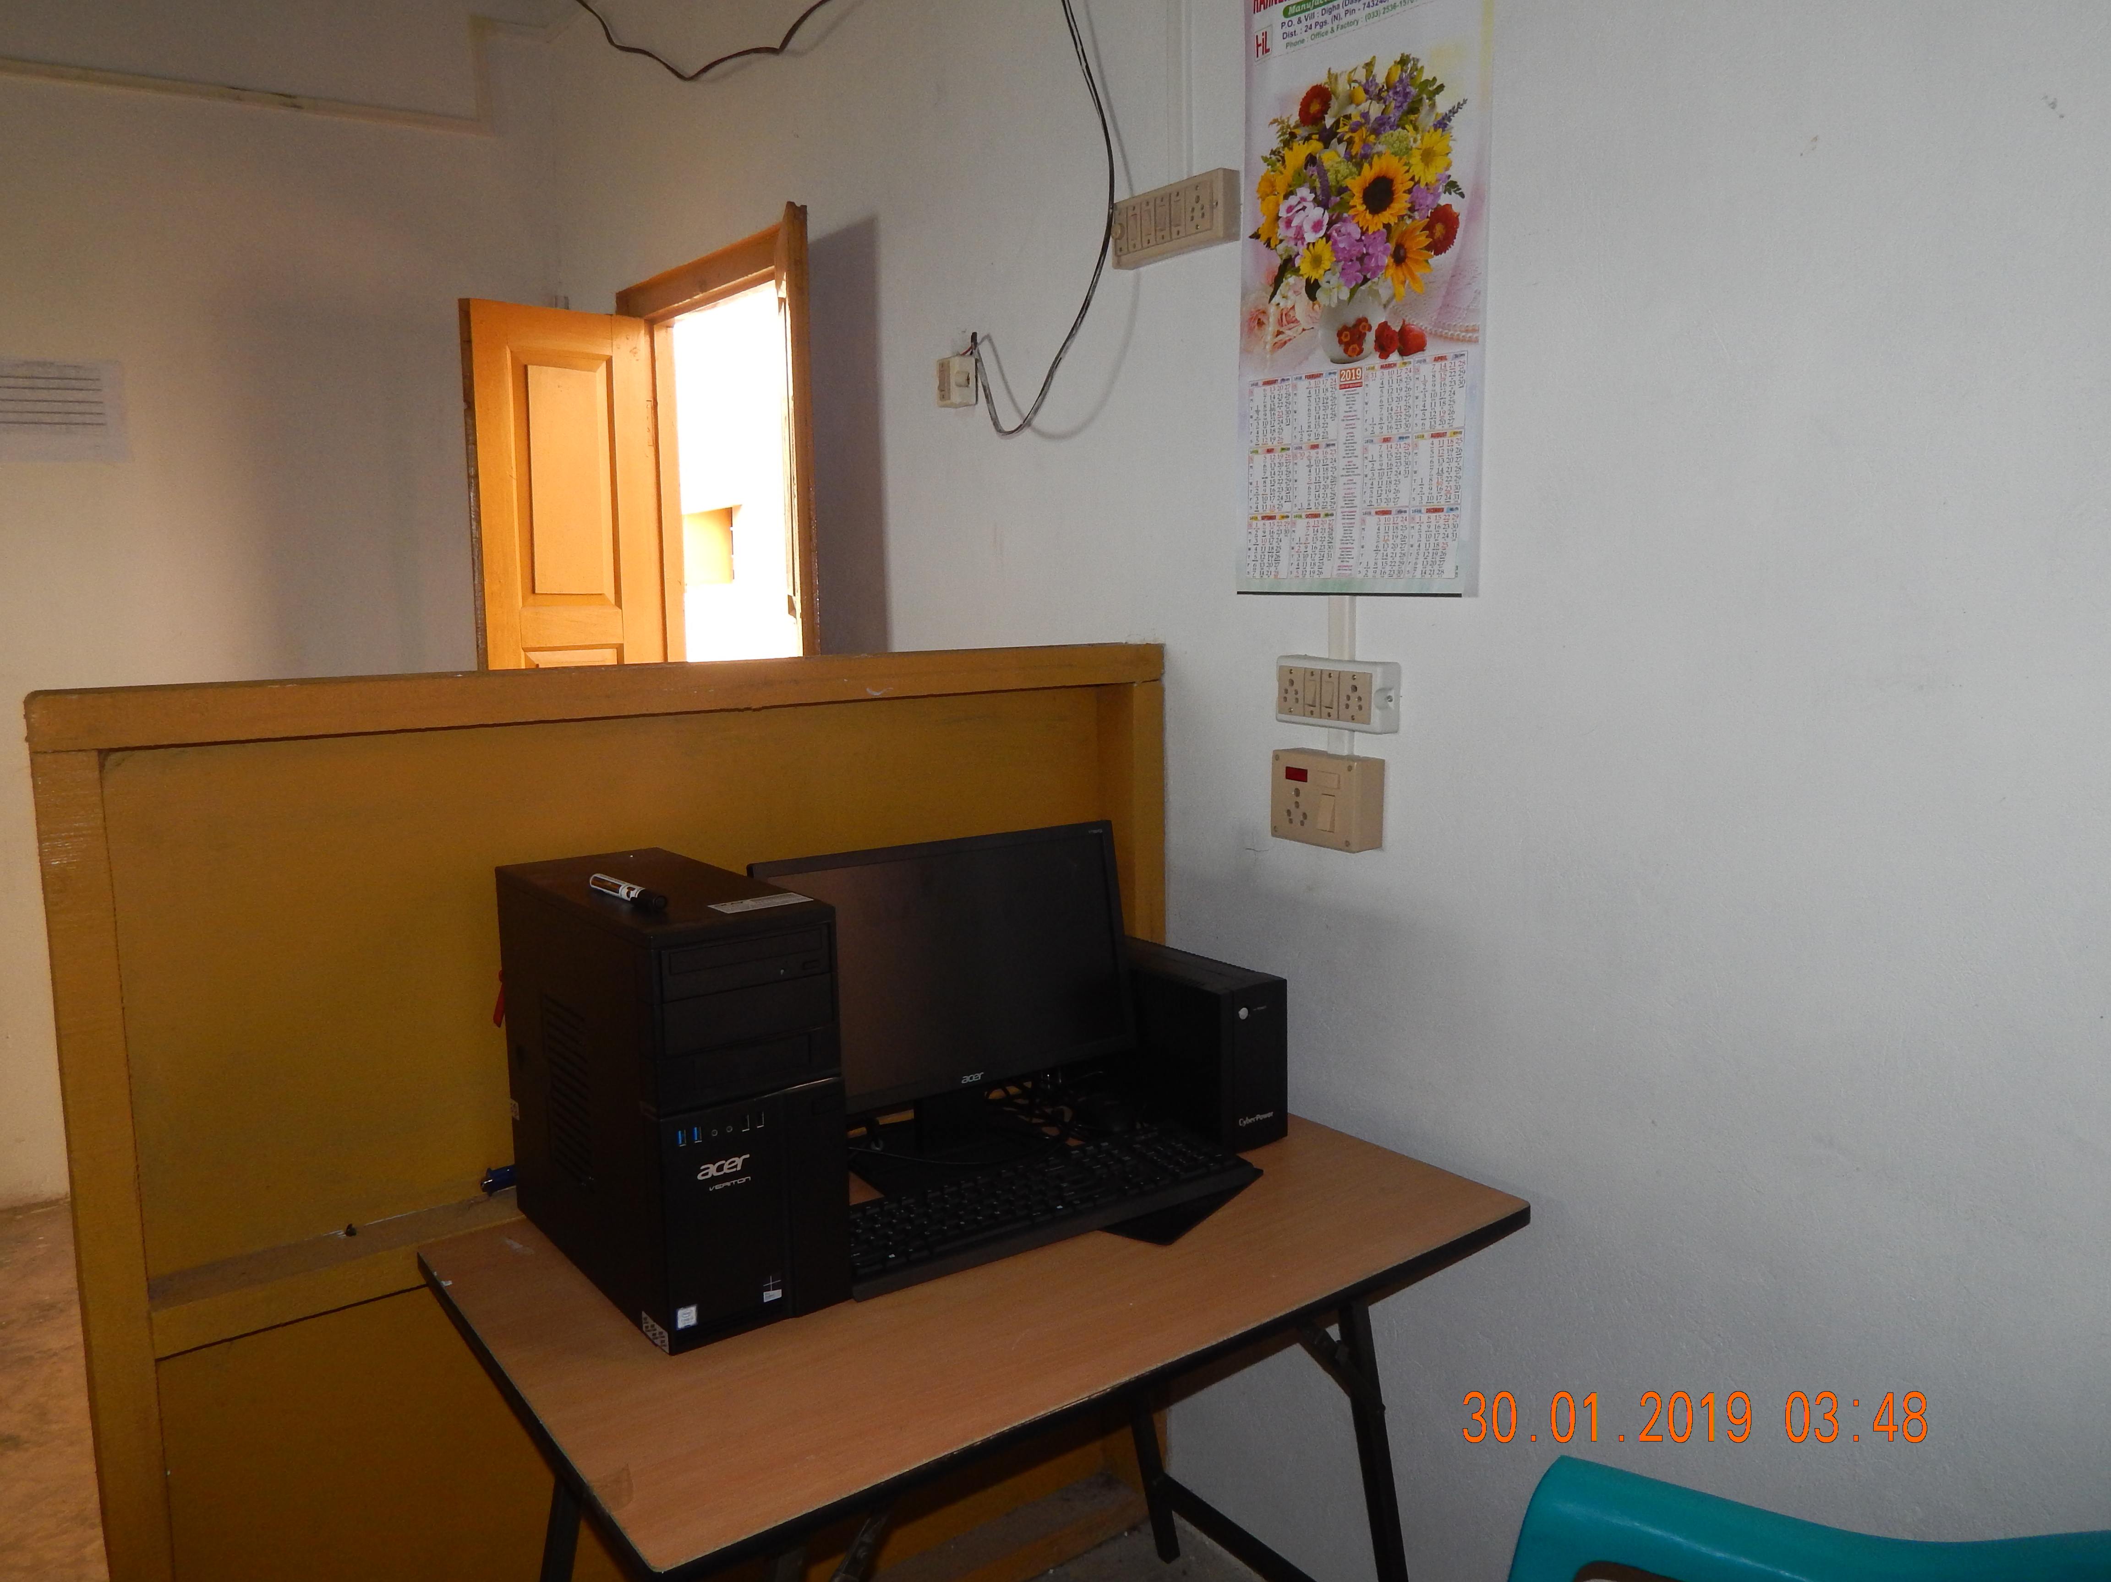
1No. Desktop PC - Department of History

Total of Number of Desktop & Laptop under procurement was 16Nos. + 1No. of Laptop Total 17Nos.
2Nos. of Monochrome Printer and 1No. of Laser Colour Printer Total 3Nos.

Procurement of Furniture Items under RUSA 1.0
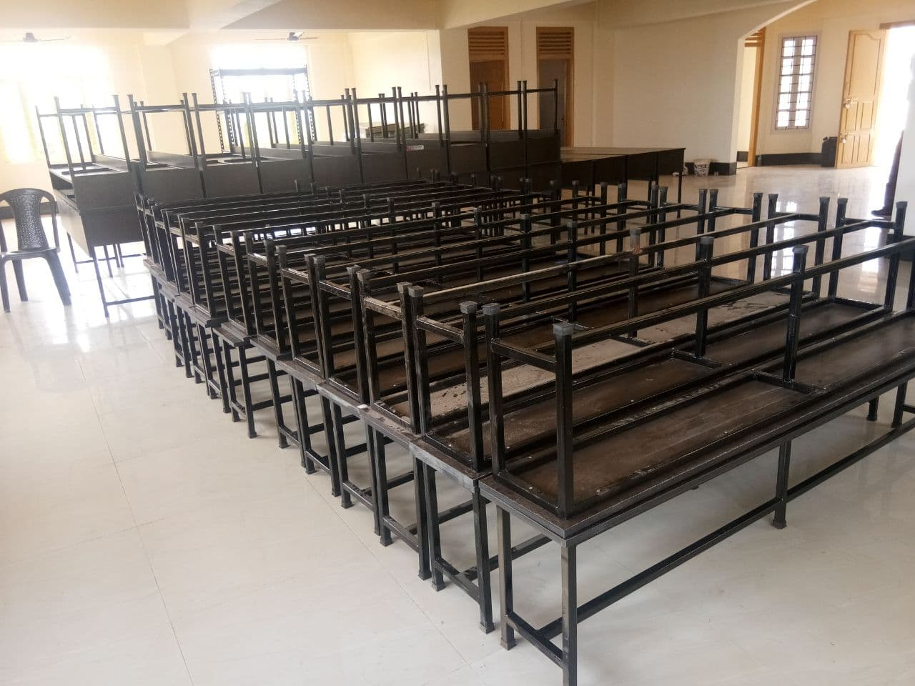
Procurement of Bench & Desk

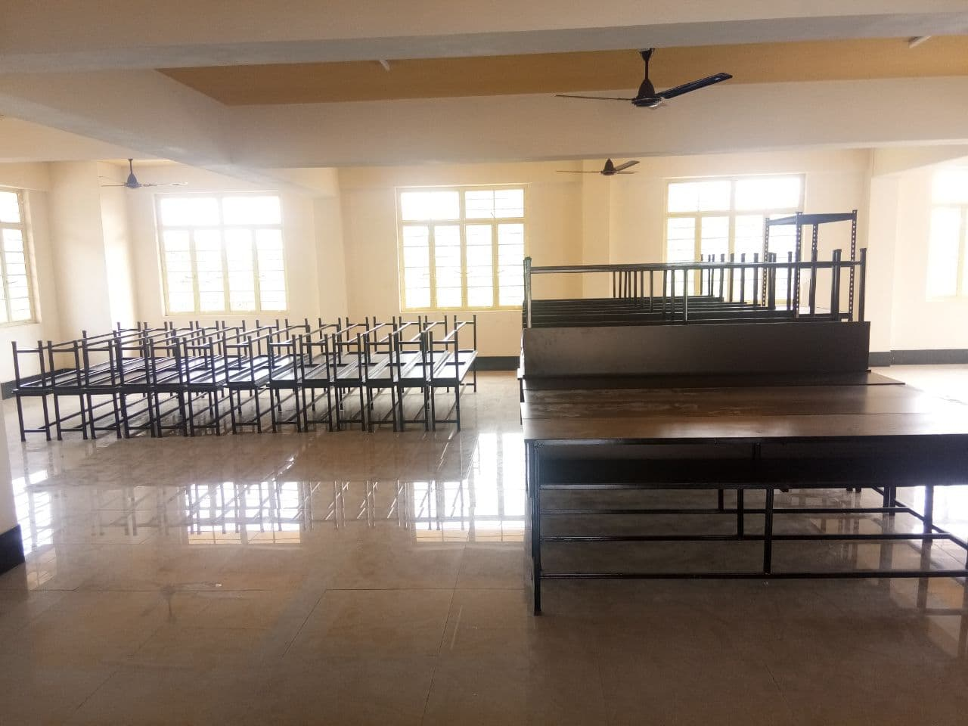
Procurement of Bench & Desk

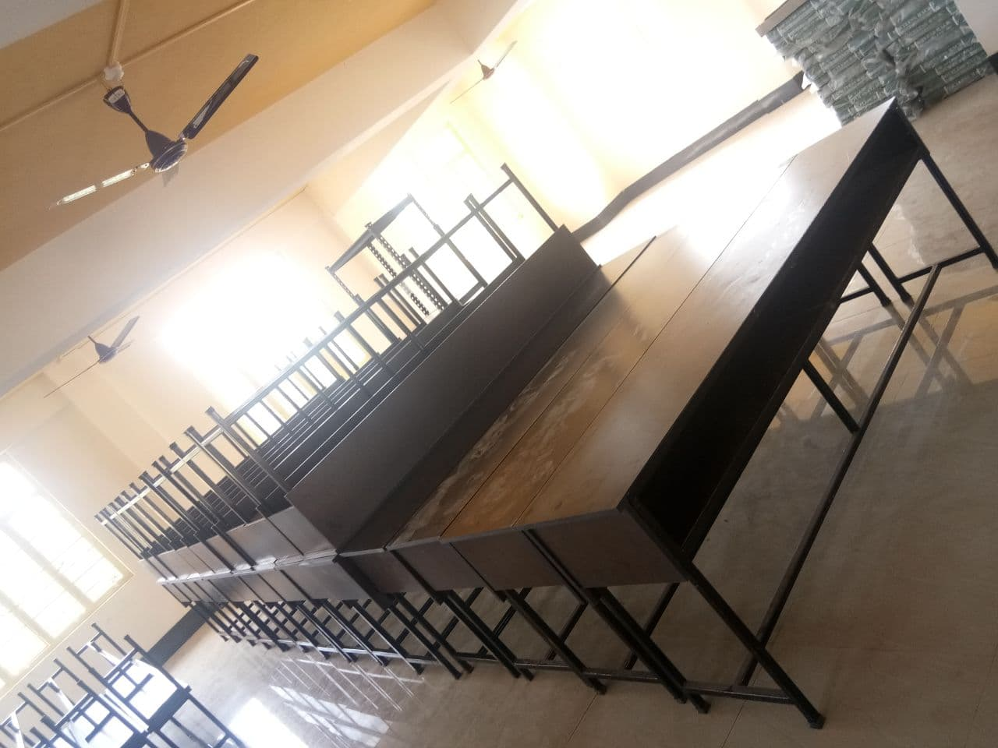
Procurement of Desk

